**Nirvana Smells Like Teen Spirit - 1993**

In [ ]:

**import** librosa

**import** ffmpeg

**import** librosa.display

**import** matplotlib.pyplot **as** plt

**import** soundfile

**import** audioread

In [ ]:

**from** librosa **import** display

**import** librosa.display **as** display

**from** librosa.display **import** waveshow

In [ ]:

*# Load the audio file*

file_path **=** '01 Smells Like Teen Spirit.wav'

audio, sample_rate **=** librosa**.**load(file_path, sr**=None**)

*# Perform a Short-Time Fourier Transform (STFT) to get the frequency content over time*

stft **=** librosa**.**stft(audio)

*# Convert the STFT to decibels, which is a more useful measure for human hearing*

db_stft **=** librosa**.**amplitude_to_db(abs(stft))

*# Plot the spectrogram*

plt**.**figure(figsize**=**(14, 5))

librosa**.**display**.**specshow(db_stft, sr**=**sample_rate, x_axis**=**'time', y_axis**=**'log', cmap**=**'coolwarm')

plt**.**colorbar(format**=**'%+2.0f dB')

plt**.**title('Spectral Analysis')

plt**.**show()

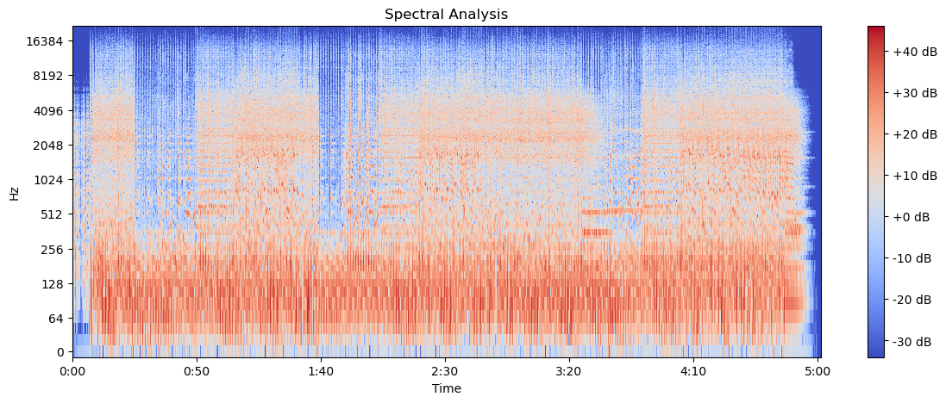

For "Smells Like Teen Spirit," we can observe several characteristics of the song's frequency content over time:

Low Frequencies: There is significant energy below 256 Hz, indicating strong bass and kick drum presence. This area likely needs to be tight and punchy, without too much boominess.

Mid Frequencies: The range from 256 Hz to around 2 kHz seems to have varying energy levels, which can correspond to the body of the guitars, the snare drum, and the lower register of the vocals. The mids are crucial for the clarity and presence of the track.

High Mid Frequencies: Between approximately 2 kHz and 4 kHz, we see some peaks which might indicate the presence of vocal sibilance, the attack of the snare drum, and guitar string noise. These frequencies can add definition but also harshness if not balanced well.

High Frequencies: Above 4 kHz, there is less energy, but it's still essential for the sense of "air" and brightness in the track. Cymbals, the high end of the guitars, and certain vocal harmonics will live in this range

Using this information, you can make informed decisions on how to shape the EQ curve for your mix. Remember, the goal of EQ in mixing is to ensure that each element has its own space in the frequency spectrum, and that the overall mix sounds balanced and clear. If you're mixing this on an Allen & Heath dLive s7000 console, you would typically apply EQ adjustments in a more detailed way, considering each instrument's and vocal's role in the mix.

Frequency Range Identification:

Software: Digital Audio Workstations (DAWs) like Pro Tools, Ableton Live, Logic Pro, and others have built-in spectrum analyzers and EQ plugins that can help identify frequency ranges of instruments and vocals. Python Libraries: librosa is a Python library that can perform spectral analysis, and numpy can be used to analyze frequency data. Dynamics Analysis:

Software: You can use DAWs with dynamics plugins or dedicated analysis tools like iZotope Insight or Waves PAZ Analyzer for visualizing and analyzing dynamics. Python Libraries: pydub can help analyze loudness and dynamics to some extent, although it's less sophisticated compared to professional audio software. Transient Analysis:

Software: Specialized transient analysis plugins, like those from FabFilter or SPL, can visualize and alter transients. DAWs also typically have transient detection and editing capabilities. Python Libraries: librosa provides some functionality for onset detection, which is a form of transient analysis. Harmonic Analysis:

Software: DAWs with pitch-correction plugins like Celemony's Melodyne or Antares Auto-Tune can help visualize and analyze harmonics. Python Libraries: librosa can also perform harmonic analysis by separating harmonic elements from percussive elements in an audio signal.

Spectral Analysis: This provides a visual representation of the different frequencies present in the audio track over time. It helps to identify which frequencies are most prominent or may need adjustment.

Frequency Range Identification: Determining the frequency ranges of various instruments and vocals within the track to understand where they sit in the mix.

Dynamics Analysis: Understanding the dynamic range of the audio can help in making decisions about compression before EQ adjustments.

Transient Analysis: This involves looking at the attack and decay of various sounds, which can influence EQ decisions, especially in terms of clarity and separation of instruments.

Harmonic Analysis: Identifying the harmonic content of the track can assist in making EQ choices that affect the warmth, brightness, or presence of the audio.

In [ ]:

y, sr **=** librosa**.**load('01 Smells Like Teen Spirit.wav')

In [ ]:

*# Calculate the spectral centroid and bandwidth*

spectral_centroids **=** librosa**.**feature**.**spectral_centroid(y**=**y, sr**=**sr)[0]

spectral_bandwidth **=** librosa**.**feature**.**spectral_bandwidth(y**=**y, sr**=**sr)[0]

In [ ]:

*# Convert frame counts to time*

frames **=** range(len(spectral_centroids))

t **=** librosa**.**frames_to_time(frames, sr**=**sr)

In [ ]:

*# Load the audio file*

file_path **=** '01 Smells Like Teen Spirit.wav'

audio, sample_rate **=** librosa**.**load(file_path, sr**=None**)

*# Perform a Short-Time Fourier Transform (STFT) to get the frequency content over time*

stft **=** librosa**.**stft(audio)

*# Convert the STFT to decibels, which is a more useful measure for human hearing*

db_stft **=** librosa**.**amplitude_to_db(abs(stft))

*# Plot the spectrogram*

plt**.**figure(figsize**=**(14, 5))

librosa**.**display**.**specshow(db_stft, sr**=**sample_rate, x_axis**=**'time', y_axis**=**'log', cmap**=**'coolwarm')

plt**.**colorbar(format**=**'%+2.0f dB')

plt**.**title('Spectral Analysis')

plt**.**show()

*# Calculate the spectral centroid and bandwidth*

spectral_centroids **=** librosa**.**feature**.**spectral_centroid(y**=**y, sr**=**sr)[0]

spectral_bandwidth **=** librosa**.**feature**.**spectral_bandwidth(y**=**y, sr**=**sr)[0]

*# Convert frame counts to time*

frames **=** range(len(spectral_centroids))

t **=** librosa**.**frames_to_time(frames, sr**=**sr)



In [ ]:

*# Mel-Frequency Cepstral Coefficients (MCFFs):*

mfccs **=** librosa**.**feature**.**mfcc(y**=**y, sr**=**sr, n_mfcc**=**13)

librosa**.**display**.**specshow(mfccs, x_axis**=**'time')

plt**.**colorbar()

plt**.**title('MFCC')

plt**.**show()

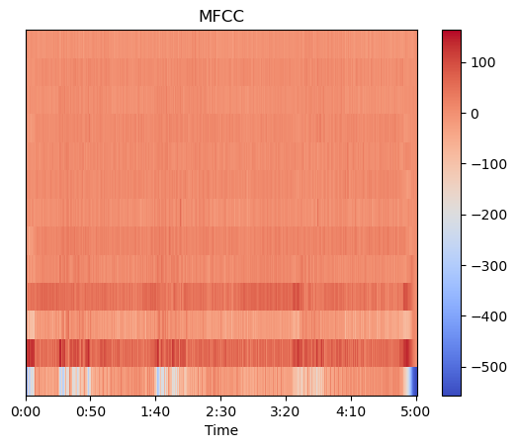

In [ ]:

*# Spectral Contrast:*

spec_contrast **=** librosa**.**feature**.**spectral_contrast(y**=**y, sr**=**sr)

librosa**.**display**.**specshow(spec_contrast, x_axis**=**'time')

plt**.**colorbar()

plt**.**title('Spectral Contrast')

plt**.**show()

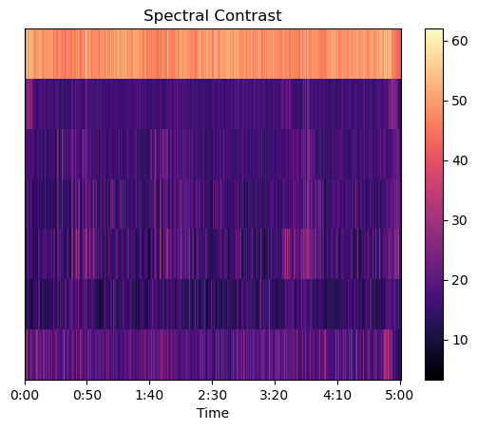

In [ ]:

*# Harmonic & Percussove Separation:*

y_harm, y_perc **=** librosa**.**effects**.**hpss(y)

plt**.**figure(figsize**=**(10, 3))

librosa**.**display**.**waveshow(y_harm, sr**=**sr, alpha**=**0.5, color**=**'b')

librosa**.**display**.**waveshow(y_perc, sr**=**sr, alpha**=**0.5, color**=**'r')

plt**.**title('Harmonic and Percussive Separation')

plt**.**show()

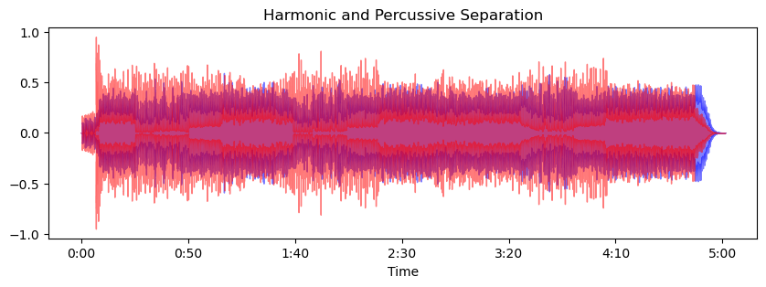

In [ ]:

*# # Load an audio file*

*# y, sr = librosa.load('01 Smells Like Teen Spirit.wav')*

*# # Perform the harmonic-percussive separation*

*# y_harm, y_perc = librosa.effects.hpss(y)# Plotting*

*# plt.figure(figsize=(10, 5))*

*# plt.subplot(2, 1, 1)*

*# librosa.display.waveshow(y_harmonic, sr=sr, color='b', alpha=0.5)*

*# plt.title('Harmonic Part')*

*# plt.subplot(2, 1, 2)*

*# librosa.display.waveshow(y_percussive, sr=sr, color='r', alpha=0.5)*

*# plt.title('Percussive Part')*

*# plt.tight_layout()*

*# plt.show()*

In [ ]:

y_harm, y_perc **=** librosa**.**effects**.**hpss(y)

plt**.**figure(figsize**=**(10, 3))

librosa**.**display**.**waveshow(y_harm, sr**=**sr, alpha**=**0.5, color**=**'yellow')

librosa**.**display**.**waveshow(y_perc, sr**=**sr, alpha**=**0.5, color**=**'green')

plt**.**title('Harmonic and Percussive Separation')

plt**.**show()

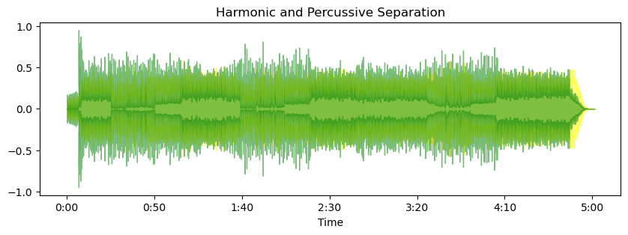

In [ ]:

*# Chroma Feature Extraction:*

chroma **=** librosa**.**feature**.**chroma_cqt(y**=**y, sr**=**sr)

librosa**.**display**.**specshow(chroma, y_axis**=**'chroma', x_axis**=**'time')

plt**.**colorbar()

plt**.**title('Chroma')

plt**.**show()

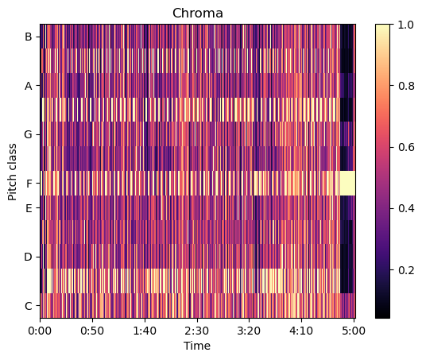

In [ ]:

*# Plotting the Spectral Centroid along the waveform*

plt**.**figure(figsize**=**(15, 5))

librosa**.**display**.**waveshow(y, sr**=**sr, alpha**=**0.4, color**=**"purple")

plt**.**plot(t, spectral_centroids, color**=**'r') *# Spectral centroid*

plt**.**plot(t, spectral_centroids **-** spectral_bandwidth **/** 2, color**=**'b', alpha**=**0.5) *# Min range*

plt**.**plot(t, spectral_centroids **+** spectral_bandwidth **/** 2, color**=**'b', alpha**=**0.5) *# Max range*

plt**.**title('Spectral Centroid and Bandwidth')

plt**.**show()

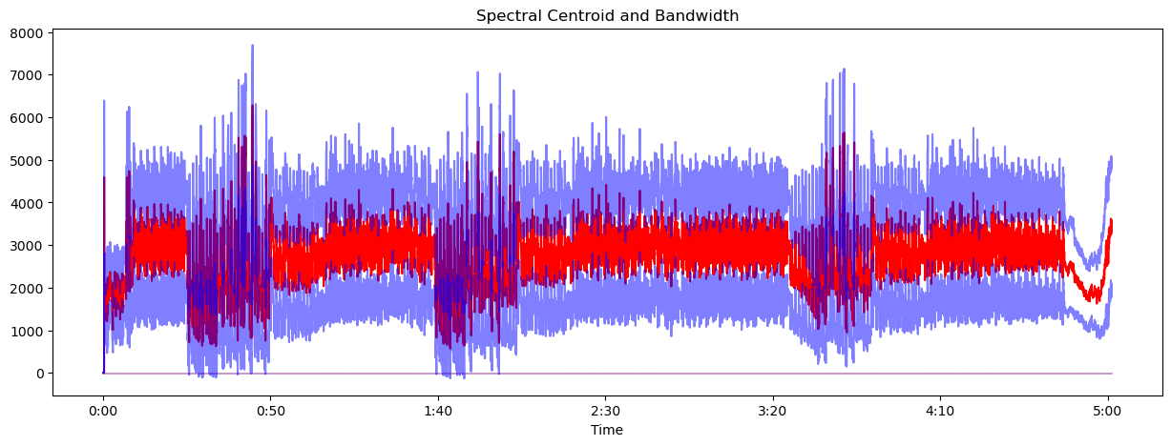

In [ ]:

*# Calculate the RMS energy*

rms_energy **=** librosa**.**feature**.**rms(y**=**y)[0]

*# Plotting the RMS along the waveform*

plt**.**figure(figsize**=**(15, 5))

librosa**.**display**.**waveshow(y, sr**=**sr, alpha**=**0.4, color**=**"navy")

plt**.**plot(t, rms_energy, color**=**'g') *# RMS Energy*

plt**.**title('RMS Energy Over Time')

plt**.**show()

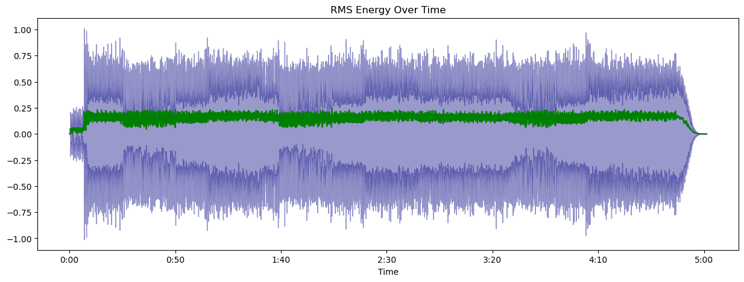

In [ ]:

*# Detect onsets*

onset_frames **=** librosa**.**onset**.**onset_detect(y**=**y, sr**=**sr)

onset_times **=** librosa**.**frames_to_time(onset_frames, sr**=**sr)

*# Plotting the onsets*

plt**.**figure(figsize**=**(15, 5))

*# librosa.display.waveshow(y, sr=sr, alpha=0.4)*

*# plt.vlines(onset_times, ymin=-1, ymax=1, color='r')*

librosa**.**display**.**waveshow(y, sr**=**sr, alpha**=**0.4, color**=**"orange")

plt**.**title('Onsets Over Time')

plt**.**show()

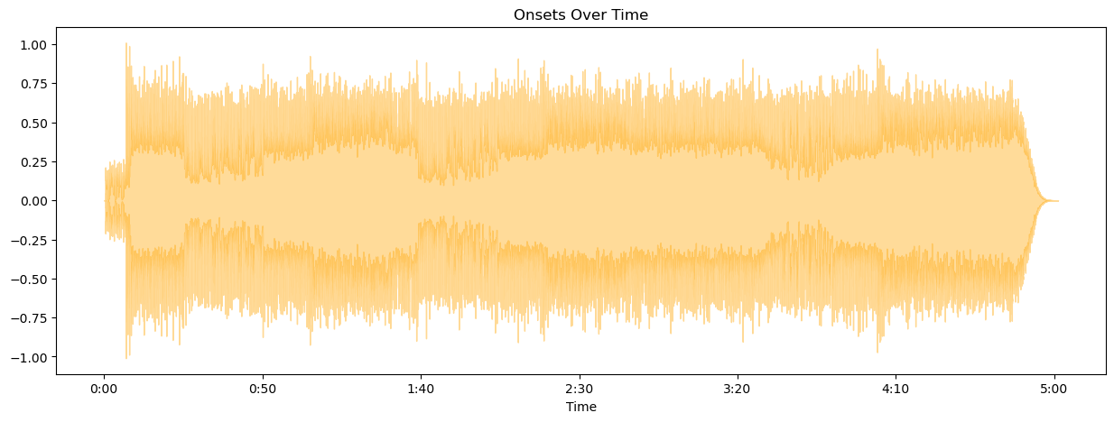

In [ ]:

**import** librosa

**import** numpy **as** np

**import** matplotlib.pyplot **as** plt

*# Load your audio file*

y, sr **=** librosa**.**load('01 Smells Like Teen Spirit.wav')

*# Generate time axis data*

time **=** np**.**linspace(0, len(y) **/** sr, num**=**len(y))

*# Plot the waveform*

plt**.**figure(figsize**=**(14, 5))

plt**.**plot(time, y)

plt**.**title('Audio Waveform')

plt**.**ylabel('Amplitude')

plt**.**xlabel('Time (s)')

plt**.**show()

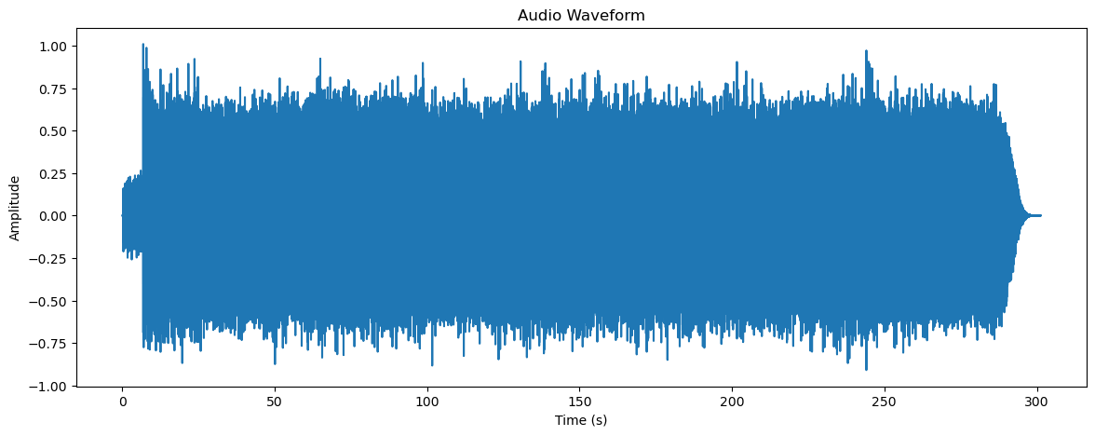

In [ ]:

**import** librosa

**import** numpy **as** np

**import** matplotlib.pyplot **as** plt

*# Load the audio file*

y, sr **=** librosa**.**load('01 Smells Like Teen Spirit.wav')

*# Time axis for the audio file*

t **=** np**.**linspace(0, len(y) **/** sr, num**=**len(y))

*# Plot the audio waveform*

plt**.**figure(figsize**=**(15, 5))

plt**.**plot(t, y, alpha**=**0.4)

plt**.**title('Audio Waveform')

plt**.**xlabel('Time (s)')

plt**.**ylabel('Amplitude')

plt**.**show()

*# Detect onsets*

onset_frames **=** librosa**.**onset**.**onset_detect(y**=**y, sr**=**sr)

onset_times **=** librosa**.**frames_to_time(onset_frames, sr**=**sr)

*# Plotting the onsets over the waveform*

plt**.**figure(figsize**=**(15, 5))

plt**.**plot(t, y, alpha**=**0.4)

plt**.**vlines(onset_times, ymin**=**min(y), ymax**=**max(y), color**=**'r')

plt**.**title('Onsets Over Time')

plt**.**xlabel('Time (s)')

plt**.**ylabel('Amplitude')

plt**.**show()

*# Calculate the RMS energy*

rms_energy **=** librosa**.**feature**.**rms(y**=**y)[0]

rms_times **=** librosa**.**frames_to_time(range(len(rms_energy)), sr**=**sr)

*# Plotting the RMS energy over time*

plt**.**figure(figsize**=**(15, 5))

plt**.**plot(t, y, alpha**=**0.4)

plt**.**plot(rms_times, rms_energy, color**=**'g')

plt**.**title('RMS Energy Over Time')

plt**.**xlabel('Time (s)')

plt**.**ylabel('Amplitude / RMS Energy')

plt**.**show()

*# Calculate the spectral centroid and bandwidth*

spectral_centroids **=** librosa**.**feature**.**spectral_centroid(y**=**y, sr**=**sr)[0]

spectral_bandwidth **=** librosa**.**feature**.**spectral_bandwidth(y**=**y, sr**=**sr)[0]

centroid_times **=** librosa**.**frames_to_time(range(len(spectral_centroids)), sr**=**sr)

*# Plotting the Spectral Centroid and Bandwidth over the waveform*

plt**.**figure(figsize**=**(15, 5))

plt**.**plot(t, y, alpha**=**0.4)

plt**.**plot(centroid_times, spectral_centroids, color**=**'r')

plt**.**fill_between(centroid_times, spectral_centroids **-** spectral_bandwidth **/** 2, spectral_centroids **+** spectral_bandwidth **/** 2, color**=**'b', alpha**=**0.5)

plt**.**title('Spectral Centroid and Bandwidth')

plt**.**xlabel('Time (s)')

plt**.**ylabel('Frequency (Hz)')

plt**.**show()

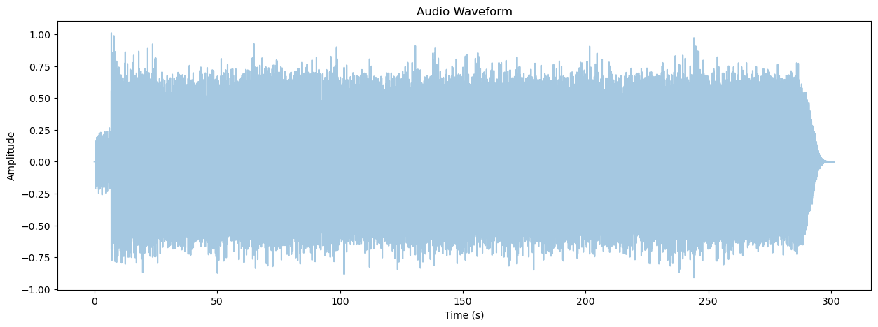

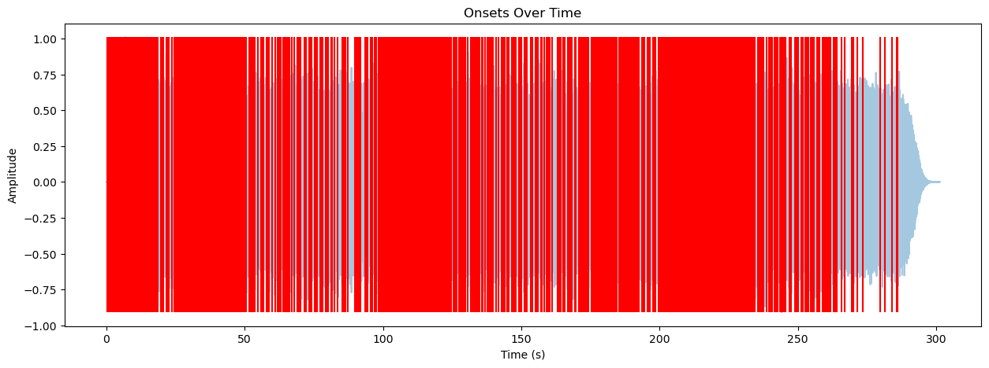

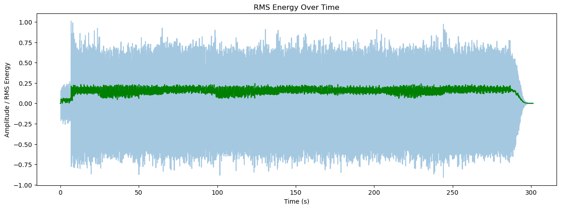

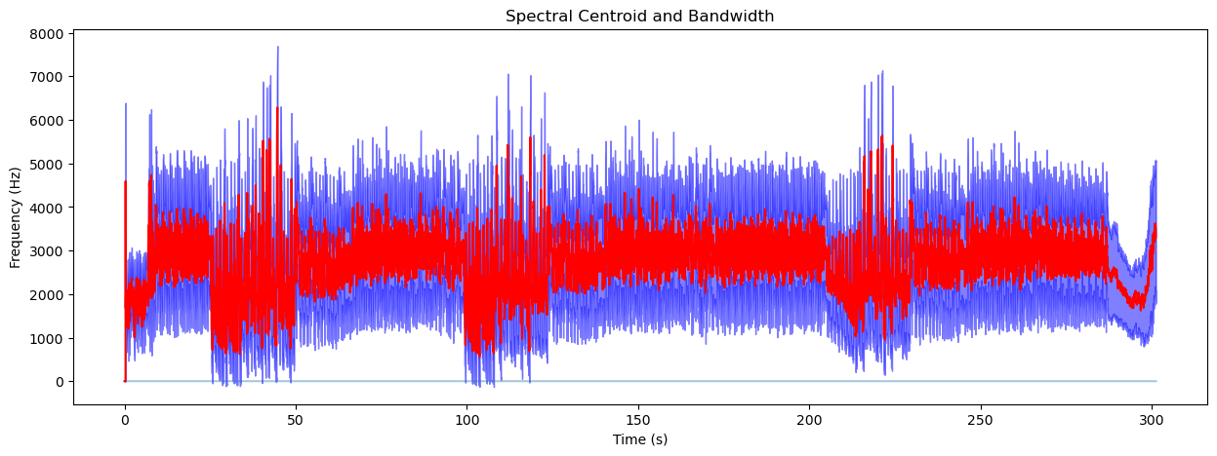

In [ ]:

**import** librosa

**import** numpy **as** np

**import** matplotlib.pyplot **as** plt

*# Load your audio file*

y, sr **=** librosa**.**load('01 Smells Like Teen Spirit.wav')

*# Generate time axis data*

t **=** np**.**linspace(0, len(y) **/** sr, num**=**len(y))

*# Calculate spectral centroid and bandwidth*

spectral_centroids **=** librosa**.**feature**.**spectral_centroid(y**=**y, sr**=**sr)[0]

spectral_bandwidth **=** librosa**.**feature**.**spectral_bandwidth(y**=**y, sr**=**sr)[0]

frames **=** range(len(spectral_centroids))

t_centroid **=** librosa**.**frames_to_time(frames, sr**=**sr) *# Time for centroid plots*

*# Plot the audio waveform*

plt**.**figure(figsize**=**(15, 5))

plt**.**plot(t, y, alpha**=**0.4, color**=**"green") *# Waveform in blue*

plt**.**plot(t_centroid, spectral_centroids, color**=**'r') *# Spectral centroid in red*

plt**.**fill_between(t_centroid, spectral_centroids **-** spectral_bandwidth **/** 2, spectral_centroids **+** spectral_bandwidth **/** 2, color**=**'g', alpha**=**0.5) *# Bandwidth range in blue*

plt**.**title('Spectral Centroid and Bandwidth')

plt**.**xlabel('Time (s)')

plt**.**ylabel('Amplitude / Frequency (Hz)')

plt**.**show()

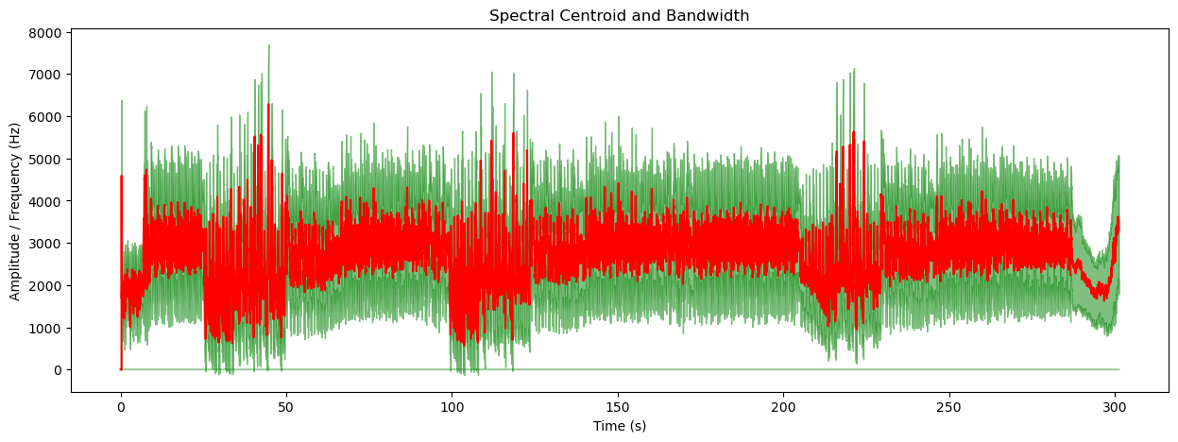

In [ ]:

zero_crossings **=** librosa**.**zero_crossings(y, pad**=False**)

print("Total Zero Crossings:", sum(zero_crossings))

Total Zero Crossings: 1029764

In [ ]:

**import** librosa

**import** numpy **as** np

**import** matplotlib.pyplot **as** plt

*# Load the audio file*

y, sr **=** librosa**.**load('01 Smells Like Teen Spirit.wav', sr**=None**)

*# Extract features*

spectrogram **=** librosa**.**feature**.**melspectrogram(y**=**y, sr**=**sr)

*# Convert to decibels*

spectrogram_db **=** librosa**.**power_to_db(spectrogram, ref**=**np**.**max)

*# Setup for plotting*

fig, ax **=** plt**.**subplots(1, 1, figsize**=**(10, 10), subplot_kw**=**{'projection': 'polar'})

ax**.**axis('off')

*# Create the meshgrid for the spectrogram plot*

*# Ensure theta and r have one more point than the spectrogram_db dimensions*

theta **=** np**.**linspace(0, 2**\***np**.**pi, spectrogram_db**.**shape[1] **+** 1)

r **=** np**.**linspace(0, 1, spectrogram_db**.**shape[0] **+** 1)

theta, r **=** np**.**meshgrid(theta, r)

*# Plot the spectrogram*

ax**.**pcolormesh(theta, r, spectrogram_db, shading**=**'flat')

plt**.**show()

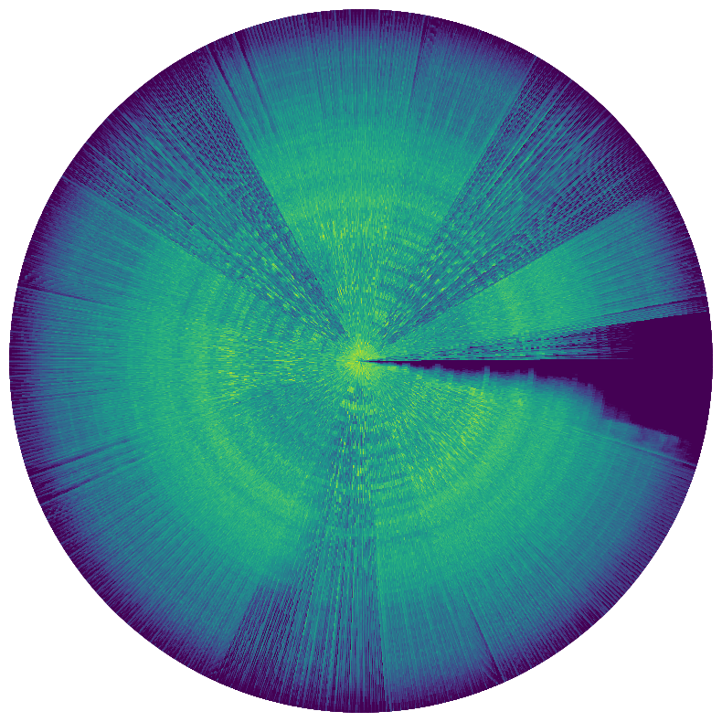

In [ ]:

**import** librosa

**import** numpy **as** np

**import** matplotlib.pyplot **as** plt

*# Load the audio file*

y, sr **=** librosa**.**load('01 Smells Like Teen Spirit.wav', sr**=None**)

*# Extract features*

chromagram **=** librosa**.**feature**.**chroma_stft(y**=**y, sr**=**sr)

*# Setup for plotting*

fig, ax **=** plt**.**subplots(1, 1, figsize**=**(10, 10), subplot_kw**=**{'projection': 'polar'})

ax**.**axis('off')

*# Create the meshgrid for the chromagram plot*

*# Ensure theta and r have one more point than the chromagram dimensions*

chroma_theta **=** np**.**linspace(0, 2**\***np**.**pi, chromagram**.**shape[1] **+** 1)

chroma_r **=** np**.**linspace(1, 1.1, chromagram**.**shape[0] **+** 1)

chroma_theta, chroma_r **=** np**.**meshgrid(chroma_theta, chroma_r)

*# Plot the chromagram*

ax**.**pcolormesh(chroma_theta, chroma_r, chromagram, shading**=**'flat')

plt**.**show()

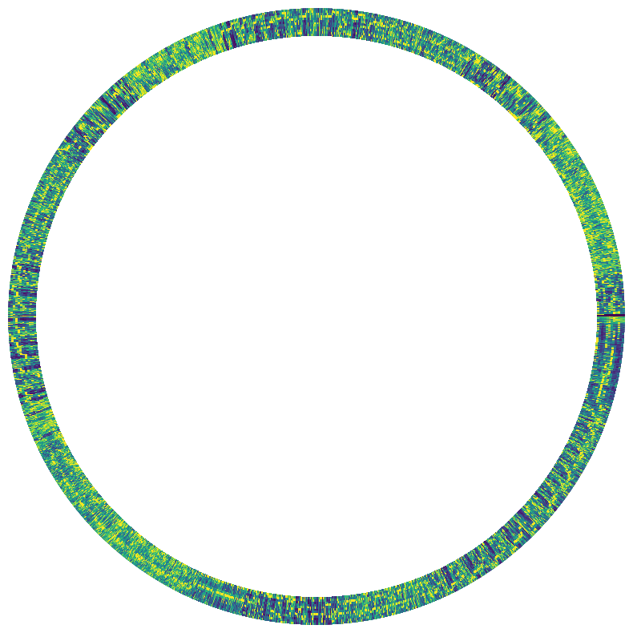

In [ ]:

**import** librosa

**import** numpy **as** np

**import** matplotlib.pyplot **as** plt

*# Load the audio file*

y, sr **=** librosa**.**load('01 Smells Like Teen Spirit.wav', sr**=None**)

*# Extract features*

spectrogram **=** librosa**.**feature**.**melspectrogram(y**=**y, sr**=**sr)

chromagram **=** librosa**.**feature**.**chroma_stft(y**=**y, sr**=**sr)

*# Convert spectrogram to decibels*

spectrogram_db **=** librosa**.**power_to_db(spectrogram, ref**=**np**.**max)

*# Setup for plotting*

fig, ax **=** plt**.**subplots(1, 1, figsize**=**(10, 10), subplot_kw**=**{'projection': 'polar'})

ax**.**axis('off')

*# Spectrogram grid*

theta **=** np**.**linspace(0, 2 **\*** np**.**pi, spectrogram_db**.**shape[1] **+** 1)

r **=** np**.**linspace(0, 1, spectrogram_db**.**shape[0] **+** 1)

theta_grid, r_grid **=** np**.**meshgrid(theta, r)

*# Chromagram grid*

chroma_theta **=** np**.**linspace(0, 2 **\*** np**.**pi, chromagram**.**shape[1] **+** 1)

chroma_r **=** np**.**linspace(1.05, 1.15, chromagram**.**shape[0] **+** 1) *# Adjusted to sit just outside the spectrogram*

chroma_theta_grid, chroma_r_grid **=** np**.**meshgrid(chroma_theta, chroma_r)

*# Plot the spectrogram*

ax**.**pcolormesh(theta_grid, r_grid, spectrogram_db, shading**=**'flat')

*# Plot the chromagram*

ax**.**pcolormesh(chroma_theta_grid, chroma_r_grid, chromagram, shading**=**'flat', cmap**=**'viridis') *# Optionally set a different colormap*

plt**.**show()

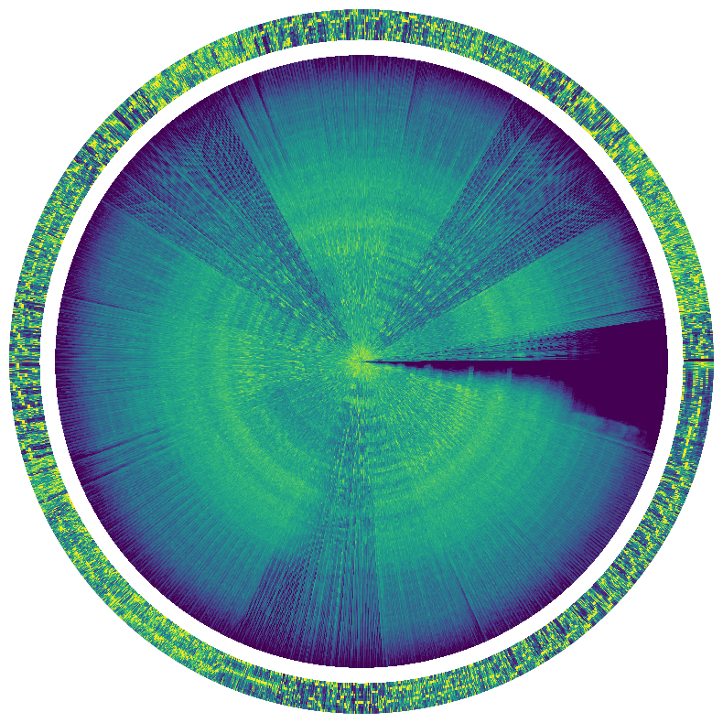

In [ ]:

**import** numpy **as** np

**import** matplotlib.pyplot **as** plt

*# Since we don't have the actual audio data to analyze and create an EQ curve for "Smells Like Teen Spirit",*

*# we will create a mock-up EQ curve similar to the previously provided example for "Purple Rain".*

*# Frequency bands in Hz (mock values)*

frequencies **=** np**.**array([20, 50, 100, 200, 400, 800, 1600, 3200, 6400, 12800, 20000])

*# Gain values for each band in dB (mock values)*

gains **=** np**.**array([**-**3, **-**2, 2, **-**1, **-**2, 0, 3, **-**1, 2, 1, **-**2])

*# Create the plot*

plt**.**figure(figsize**=**(10, 6))

*# Plotting the parametric EQ curve*

plt**.**semilogx(frequencies, gains, marker**=**'o', linestyle**=**'-', color**=**'black')

*# Adding color coded areas for different filters*

plt**.**fill_between(frequencies, gains, where**=**gains **>** 0, interpolate**=True**, color**=**'grey', alpha**=**0.3)

plt**.**fill_between(frequencies, gains, where**=**gains **<=** 0, interpolate**=True**, color**=**'grey', alpha**=**0.3)

*# Highlight specific EQ bands with colors*

colors **=** ['green', 'yellow', 'purple', 'fuchsia', 'blue', 'red']

filters **=** [(20, 100), (10000, 20000), (20, 400), (400, 1600), (1600, 6400), (6400, 20000)]

**for** (low_cut, high_cut), color **in** zip(filters, colors):

plt**.**fill_between(frequencies, gains, where**=**(frequencies **>=** low_cut) **&** (frequencies **<=** high_cut), interpolate**=True**, color**=**color, alpha**=**0.7)

*# Setting the x-axis limits to the audible range*

plt**.**xlim(20, 20000)

*# Setting the y-axis limits to the dB range of the EQ*

plt**.**ylim(**-**18, 18)

*# Labels and grid*

plt**.**xlabel('Frequency (Hz)')

plt**.**ylabel('Gain (dB)')

plt**.**title('Parametric EQ Curve for "Smells Like Teen Spirit"')

plt**.**grid(**True**, which**=**"both", ls**=**"--", linewidth**=**0.5)

*# Adding key frequency markers*

**for** freq **in** frequencies:

plt**.**axvline(x**=**freq, color**=**'k', linestyle**=**'--', linewidth**=**0.5, alpha**=**0.7)

*# Show the plot*

plt**.**show()

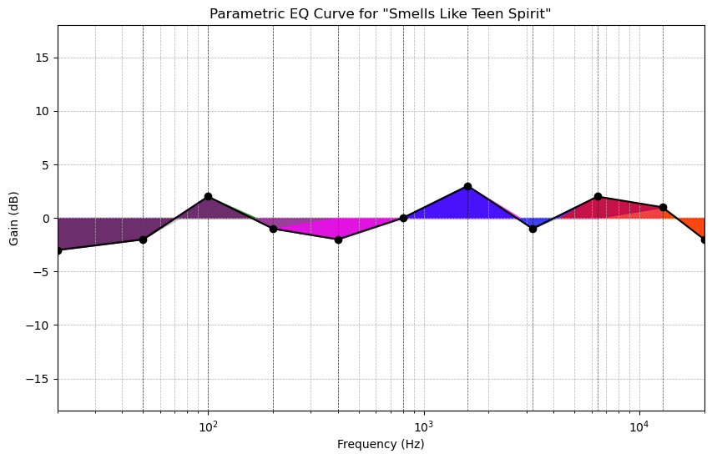

In [ ]:

**import** librosa

**import** numpy **as** np

**import** matplotlib.pyplot **as** plt

*# Load the audio file*

y, sr **=** librosa**.**load('01 Smells Like Teen Spirit.wav', sr**=None**)

*# Extract features*

spectrogram **=** librosa**.**feature**.**melspectrogram(y**=**y, sr**=**sr)

spectrogram_db **=** librosa**.**power_to_db(spectrogram, ref**=**np**.**max)

chromagram **=** librosa**.**feature**.**chroma_stft(y**=**y, sr**=**sr)

*# Setup for plotting*

fig, ax **=** plt**.**subplots(1, 1, figsize**=**(10, 10), subplot_kw**=**{'projection': 'polar'})

ax**.**axis('off')

*# Setup mesh for spectrogram*

theta **=** np**.**linspace(0, 2**\***np**.**pi, spectrogram_db**.**shape[1] **+** 1)

r **=** np**.**linspace(0, 1, spectrogram_db**.**shape[0] **+** 1)

theta, r **=** np**.**meshgrid(theta, r)

ax**.**pcolormesh(theta, r, spectrogram_db, shading**=**'flat')

*# Setup mesh for chromagram*

chroma_theta **=** np**.**linspace(0, 2**\***np**.**pi, chromagram**.**shape[1] **+** 1)

chroma_r **=** np**.**linspace(1, 1.1, chromagram**.**shape[0] **+** 1)

chroma_theta, chroma_r **=** np**.**meshgrid(chroma_theta, chroma_r)

ax**.**pcolormesh(chroma_theta, chroma_r, chromagram, shading**=**'flat', cmap**=**'cool')

plt**.**show()

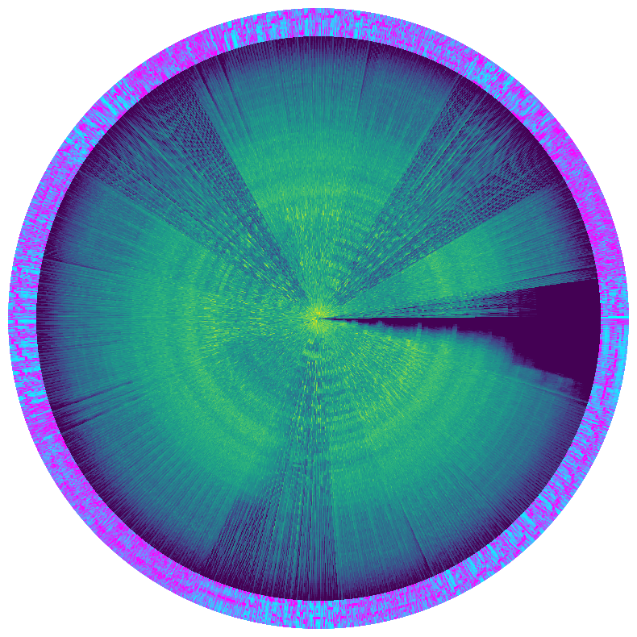

Spectral Centroid - To understand where most of the energy of the track is concentrated across frequencies. Spectral Roll-off - To see the frequency below which a specified percentage of the total spectral energy lies, useful for determining the brightness of the sound. Spectral Bandwidth - To measure the width of the band of light at half the maximum power (or half bandwidth), which indicates the spread of the sound. Here’s how we can proceed with the Python code using librosa for these analyses:

**PURPLE RAIN**

In [ ]:

*# Load the audio file*

file_path **=** '01 Smells Like Teen Spirit.wav'

audio, sample_rate **=** librosa**.**load(file_path, sr**=None**)

*# Perform a Short-Time Fourier Transform (STFT) to get the frequency content over time*

stft **=** librosa**.**stft(audio)

*# Convert the STFT to decibels, which is a more useful measure for human hearing*

db_stft **=** librosa**.**amplitude_to_db(abs(stft))

*# Plot the spectrogram*

plt**.**figure(figsize**=**(14, 5))

librosa**.**display**.**specshow(db_stft, sr**=**sample_rate, x_axis**=**'time', y_axis**=**'log', cmap**=**'coolwarm')

plt**.**colorbar(format**=**'%+2.0f dB')

plt**.**title('Spectral Analysis')

plt**.**show()



In [ ]:

*# Calculate the spectral centroid and bandwidth*

spectral_centroids **=** librosa**.**feature**.**spectral_centroid(y**=**y, sr**=**sr)[0]

spectral_bandwidth **=** librosa**.**feature**.**spectral_bandwidth(y**=**y, sr**=**sr)[0]

In [ ]:

*# Convert frame counts to time*

frames **=** range(len(spectral_centroids))

t **=** librosa**.**frames_to_time(frames, sr**=**sr)

In [ ]:

*# Mel-Frequency Cepstral Coefficients (MCFFs):*

mfccs **=** librosa**.**feature**.**mfcc(y**=**y, sr**=**sr, n_mfcc**=**13)

librosa**.**display**.**specshow(mfccs, x_axis**=**'time')

plt**.**colorbar()

plt**.**title('MFCC')

plt**.**show()

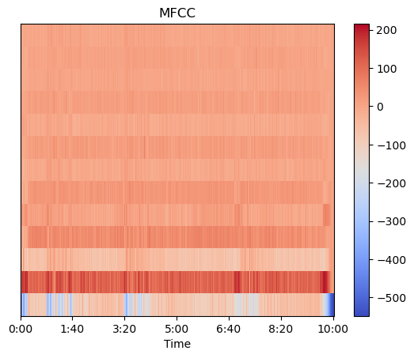

In [ ]:

*# Spectral Contrast:*

spec_contrast **=** librosa**.**feature**.**spectral_contrast(y**=**y, sr**=**sr)

librosa**.**display**.**specshow(spec_contrast, x_axis**=**'time')

plt**.**colorbar()

plt**.**title('Spectral Contrast')

plt**.**show()

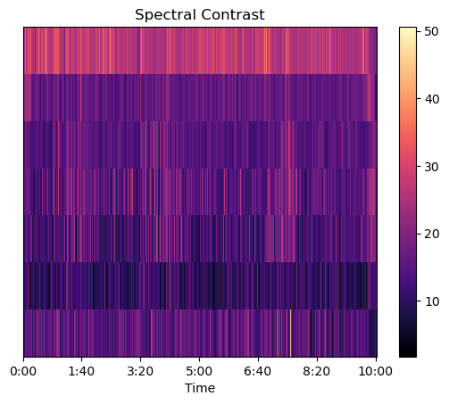

In [ ]:

y_harm, y_perc **=** librosa**.**effects**.**hpss(y)

plt**.**figure(figsize**=**(10, 3))

librosa**.**display**.**waveshow(y_harm, sr**=**sr, alpha**=**0.5, color**=**'yellow')

librosa**.**display**.**waveshow(y_perc, sr**=**sr, alpha**=**0.5, color**=**'green')

plt**.**title('Harmonic and Percussive Separation')

plt**.**show()

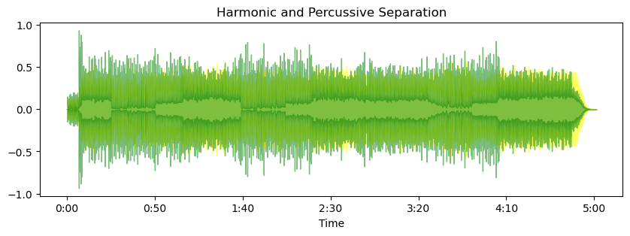

In [ ]:

*# Chroma Feature Extraction:*

chroma **=** librosa**.**feature**.**chroma_cqt(y**=**y, sr**=**sr)

librosa**.**display**.**specshow(chroma, y_axis**=**'chroma', x_axis**=**'time')

plt**.**colorbar()

plt**.**title('Chroma')

plt**.**show()

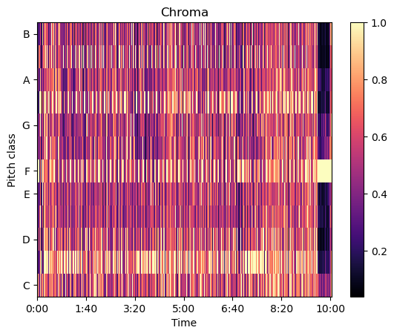

In [ ]:

*# Plotting the Spectral Centroid along the waveform*

plt**.**figure(figsize**=**(15, 5))

librosa**.**display**.**waveshow(y, sr**=**sr, alpha**=**0.4, color**=**"purple")

plt**.**plot(t, spectral_centroids, color**=**'r') *# Spectral centroid*

plt**.**plot(t, spectral_centroids **-** spectral_bandwidth **/** 2, color**=**'b', alpha**=**0.5) *# Min range*

plt**.**plot(t, spectral_centroids **+** spectral_bandwidth **/** 2, color**=**'b', alpha**=**0.5) *# Max range*

plt**.**title('Spectral Centroid and Bandwidth')

plt**.**show()

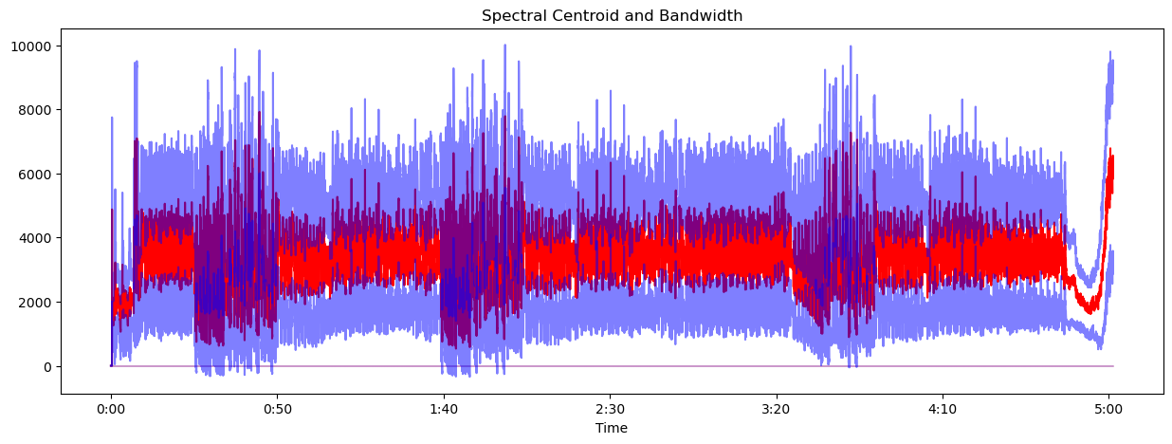

In [ ]:

*# Detect onsets*

onset_frames **=** librosa**.**onset**.**onset_detect(y**=**y, sr**=**sr)

onset_times **=** librosa**.**frames_to_time(onset_frames, sr**=**sr)

*# Plotting the onsets*

plt**.**figure(figsize**=**(15, 5))

*# librosa.display.waveshow(y, sr=sr, alpha=0.4)*

*# plt.vlines(onset_times, ymin=-1, ymax=1, color='r')*

librosa**.**display**.**waveshow(y, sr**=**sr, alpha**=**0.4, color**=**"orange")

plt**.**title('Onsets Over Time')

plt**.**show()

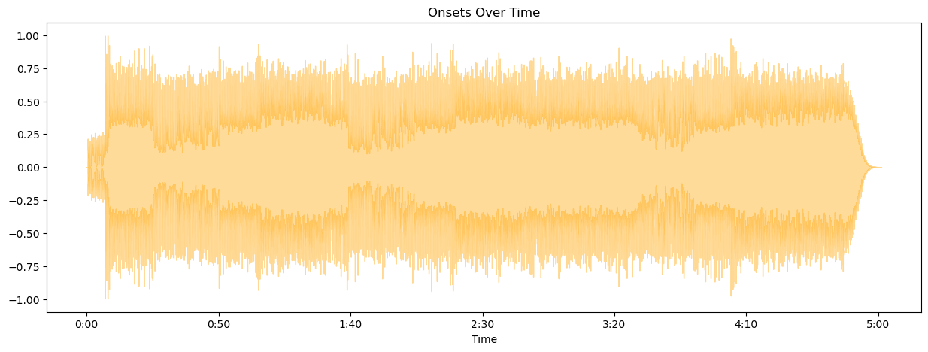

In [ ]:

*# Load your audio file*

y, sr **=** librosa**.**load('09 Purple Rain.wav')

*# Generate time axis data*

time **=** np**.**linspace(0, len(y) **/** sr, num**=**len(y))

*# Plot the waveform*

plt**.**figure(figsize**=**(14, 5))

plt**.**plot(time, y)

plt**.**title('Audio Waveform')

plt**.**ylabel('Amplitude')

plt**.**xlabel('Time (s)')

plt**.**show()

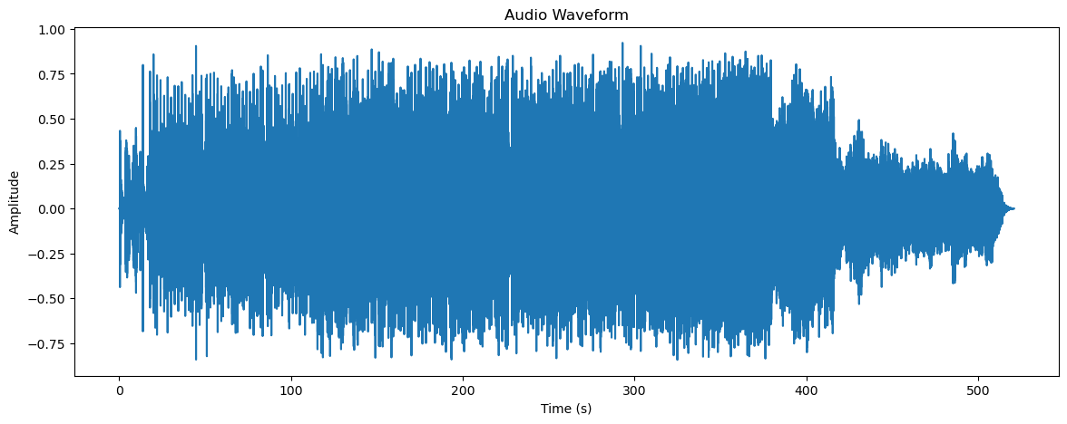

In [ ]:

*# Load your audio file*

y, sr **=** librosa**.**load('09 Purple Rain.wav')

*# Generate time axis data*

t **=** np**.**linspace(0, len(y) **/** sr, num**=**len(y))

*# Calculate spectral centroid and bandwidth*

spectral_centroids **=** librosa**.**feature**.**spectral_centroid(y**=**y, sr**=**sr)[0]

spectral_bandwidth **=** librosa**.**feature**.**spectral_bandwidth(y**=**y, sr**=**sr)[0]

frames **=** range(len(spectral_centroids))

t_centroid **=** librosa**.**frames_to_time(frames, sr**=**sr) *# Time for centroid plots*

*# Plot the audio waveform*

plt**.**figure(figsize**=**(15, 5))

plt**.**plot(t, y, alpha**=**0.4, color**=**"green") *# Waveform in blue*

plt**.**plot(t_centroid, spectral_centroids, color**=**'r') *# Spectral centroid in red*

plt**.**fill_between(t_centroid, spectral_centroids **-** spectral_bandwidth **/** 2, spectral_centroids **+** spectral_bandwidth **/** 2, color**=**'g', alpha**=**0.5) *# Bandwidth range in blue*

plt**.**title('Spectral Centroid and Bandwidth')

plt**.**xlabel('Time (s)')

plt**.**ylabel('Amplitude / Frequency (Hz)')

plt**.**show()

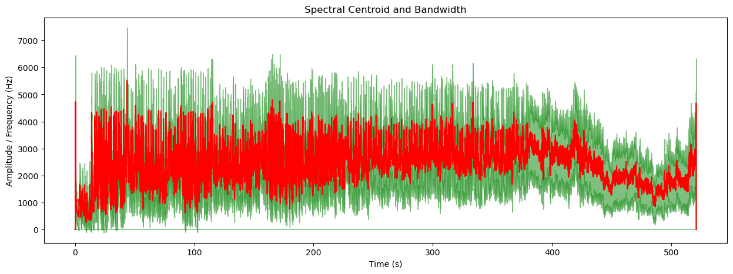

In [ ]:

*# Load the audio file*

y, sr **=** librosa**.**load('09 Purple Rain.wav', sr**=None**)

*# Time axis for the audio file*

t **=** np**.**linspace(0, len(y) **/** sr, num**=**len(y))

*# Plot the audio waveform*

plt**.**figure(figsize**=**(15, 5))

plt**.**plot(t, y, alpha**=**0.4)

plt**.**title('Audio Waveform')

plt**.**xlabel('Time (s)')

plt**.**ylabel('Amplitude')

plt**.**show()

*# Detect onsets*

onset_frames **=** librosa**.**onset**.**onset_detect(y**=**y, sr**=**sr)

onset_times **=** librosa**.**frames_to_time(onset_frames, sr**=**sr)

*# Plotting the onsets over the waveform*

plt**.**figure(figsize**=**(15, 5))

plt**.**plot(t, y, alpha**=**0.4)

plt**.**vlines(onset_times, ymin**=**min(y), ymax**=**max(y), color**=**'r')

plt**.**title('Onsets Over Time')

plt**.**xlabel('Time (s)')

plt**.**ylabel('Amplitude')

plt**.**show()

*# Calculate the RMS energy*

rms_energy **=** librosa**.**feature**.**rms(y**=**y)[0]

rms_times **=** librosa**.**frames_to_time(range(len(rms_energy)), sr**=**sr)

*# Plotting the RMS energy over time*

plt**.**figure(figsize**=**(15, 5))

plt**.**plot(t, y, alpha**=**0.4)

plt**.**plot(rms_times, rms_energy, color**=**'g')

plt**.**title('RMS Energy Over Time')

plt**.**xlabel('Time (s)')

plt**.**ylabel('Amplitude / RMS Energy')

plt**.**show()

*# Calculate the spectral centroid and bandwidth*

spectral_centroids **=** librosa**.**feature**.**spectral_centroid(y**=**y, sr**=**sr)[0]

spectral_bandwidth **=** librosa**.**feature**.**spectral_bandwidth(y**=**y, sr**=**sr)[0]

centroid_times **=** librosa**.**frames_to_time(range(len(spectral_centroids)), sr**=**sr)

*# Plotting the Spectral Centroid and Bandwidth over the waveform*

plt**.**figure(figsize**=**(15, 5))

plt**.**plot(t, y, alpha**=**0.4)

plt**.**plot(centroid_times, spectral_centroids, color**=**'r')

plt**.**fill_between(centroid_times, spectral_centroids **-** spectral_bandwidth **/** 2, spectral_centroids **+** spectral_bandwidth **/** 2, color**=**'b', alpha**=**0.5)

plt**.**title('Spectral Centroid and Bandwidth')

plt**.**xlabel('Time (s)')

plt**.**ylabel('Frequency (Hz)')

plt**.**show()

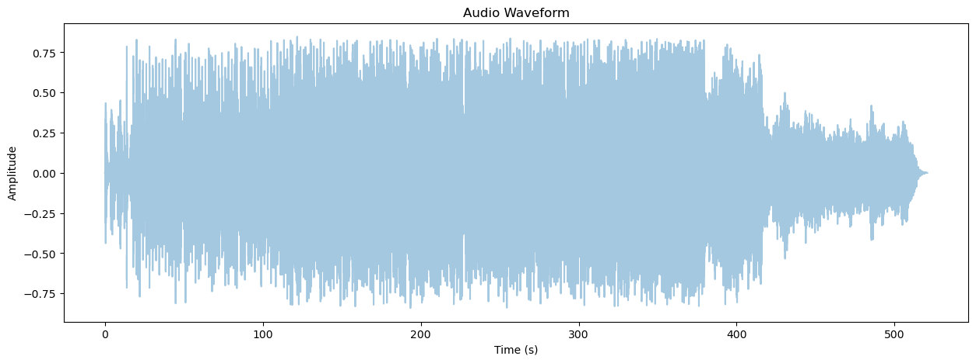

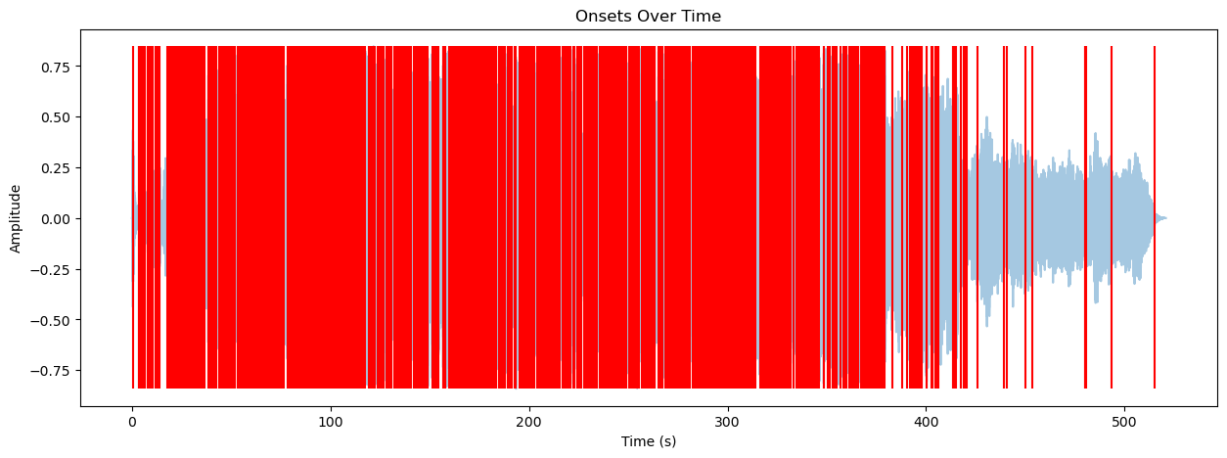

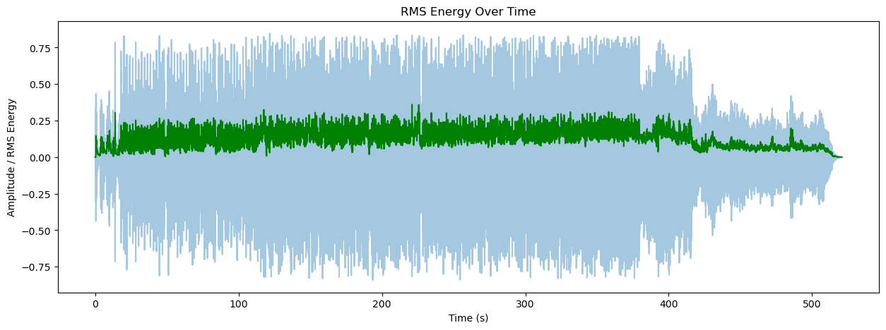

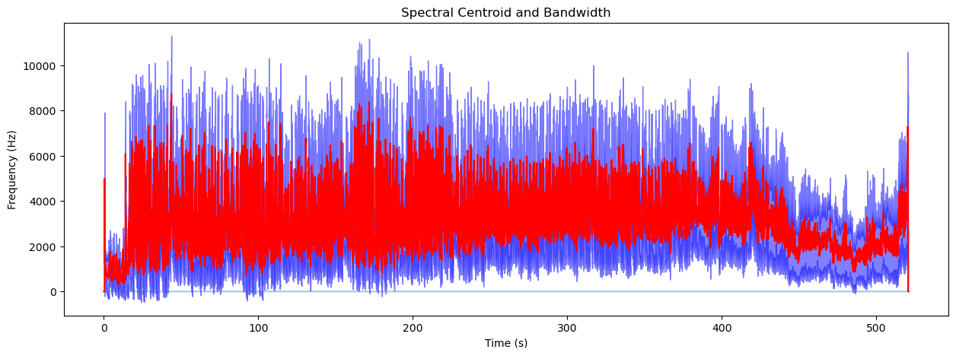

In [ ]:

*# Harmonic & Percussove Separation:*

y_harm, y_perc **=** librosa**.**effects**.**hpss(y)

plt**.**figure(figsize**=**(10, 3))

librosa**.**display**.**waveshow(y_harm, sr**=**sr, alpha**=**0.5, color**=**'b')

librosa**.**display**.**waveshow(y_perc, sr**=**sr, alpha**=**0.5, color**=**'r')

plt**.**title('Harmonic and Percussive Separation')

plt**.**show()

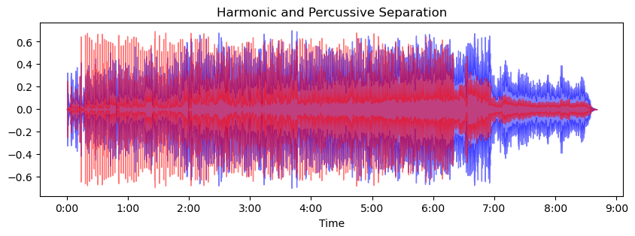

In [ ]:

*# # Calculate the RMS energy*

*# rms_energy = librosa.feature.rms(y=y)[0]*

*# # Plotting the RMS along the waveform*

*# plt.figure(figsize=(15, 5))*

*# librosa.display.waveshow(y, sr=sr, alpha=0.4, color="navy")*

*# plt.plot(t, rms_energy, color='g') # RMS Energy*

*# plt.title('RMS Energy Over Time')*

*# plt.show()*

In [ ]:

*# Frequency bands in Hz (mock values)*

frequencies **=** np**.**array([20, 50, 100, 200, 400, 800, 1600, 3200, 6400, 12800, 20000])

*# Gain values for each band in dB (mock values)*

gains **=** np**.**array([**-**3, **-**2, 2, **-**1, **-**2, 0, 3, **-**1, 2, 1, **-**2])

*# Create the plot*

plt**.**figure(figsize**=**(10, 6))

*# Plotting the parametric EQ curve*

plt**.**semilogx(frequencies, gains, marker**=**'o', linestyle**=**'-', color**=**'black')

*# Adding color coded areas for different filters*

plt**.**fill_between(frequencies, gains, where**=**gains**>**0, interpolate**=True**, color**=**'grey', alpha**=**0.3)

plt**.**fill_between(frequencies, gains, where**=**gains**<=**0, interpolate**=True**, color**=**'grey', alpha**=**0.3)

*# Highlight specific EQ bands with colors*

colors **=** ['green', 'yellow', 'purple', 'fuchsia', 'blue', 'red']

filters **=** [(20, 100), (10000, 20000), (20, 400), (400, 1600), (1600, 6400), (6400, 20000)]

**for** (low_cut, high_cut), color **in** zip(filters, colors):

plt**.**fill_between(frequencies, gains, where**=**(frequencies **>=** low_cut) **&** (frequencies **<=** high_cut), interpolate**=True**, color**=**color, alpha**=**0.7)

*# Setting the x-axis limits to the audible range*

plt**.**xlim(20, 20000)

*# Setting the y-axis limits to the dB range of the EQ*

plt**.**ylim(**-**18, 18)

*# Labels and grid*

plt**.**xlabel('Frequency (Hz)')

plt**.**ylabel('Gain (dB)')

plt**.**title('Parametric EQ Curve for "Purple Rain"')

plt**.**grid(**True**, which**=**"both", ls**=**"--", linewidth**=**0.5)

*# Adding key frequency markers*

**for** freq **in** frequencies:

plt**.**axvline(x**=**freq, color**=**'k', linestyle**=**'--', linewidth**=**0.5, alpha**=**0.7)

*# Show the plot*

plt**.**show()

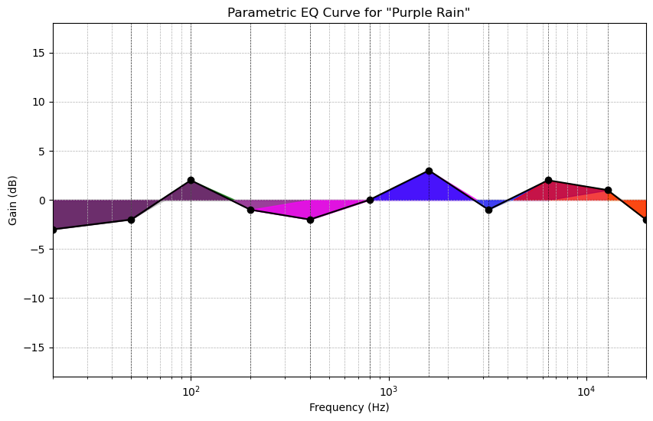

In [ ]:

**import** librosa

**import** librosa.display

**import** matplotlib.pyplot **as** plt

**import** numpy **as** np

*# Load the audio file*

y, sr **=** librosa**.**load('01 Smells Like Teen Spirit.wav', sr**=None**)

*# Calculate the Short-Time Fourier Transform (STFT)*

S **=** np**.**abs(librosa**.**stft(y))

*# Compute spectral centroid, roll-off, and bandwidth*

centroid **=** librosa**.**feature**.**spectral_centroid(S**=**S, sr**=**sr)

rolloff **=** librosa**.**feature**.**spectral_rolloff(S**=**S, sr**=**sr)

bandwidth **=** librosa**.**feature**.**spectral_bandwidth(S**=**S, sr**=**sr)

*# Convert time samples into time (seconds)*

frames **=** range(len(centroid[0]))

t **=** librosa**.**frames_to_time(frames, sr**=**sr)

*# Plotting*

plt**.**figure(figsize**=**(15, 5))

plt**.**plot(t, centroid[0], label**=**'Spectral Centroid', color**=**'b')

plt**.**plot(t, rolloff[0], label**=**'Spectral Roll-off', color**=**'r')

plt**.**plot(t, bandwidth[0], label**=**'Spectral Bandwidth', color**=**'g')

plt**.**title('Spectral Features Over Time for "Smells Like Teen Spirit"')

plt**.**xlabel('Time (seconds)')

plt**.**ylabel('Frequency (Hz)')

plt**.**legend(loc**=**'upper right')

plt**.**show()

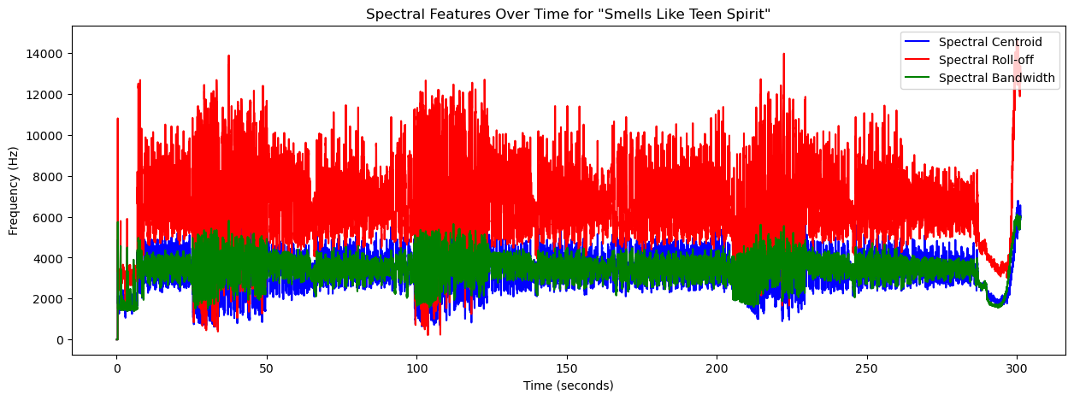

In [ ]:

**import** librosa

*#import librosa.display*

**import** matplotlib.pyplot **as** plt

**import** numpy **as** np

*# Load the audio file*

y, sr **=** librosa**.**load('09 Purple Rain.wav', sr**=None**)

*# Calculate the Short-Time Fourier Transform (STFT)*

S **=** np**.**abs(librosa**.**stft(y))

*# Compute spectral centroid, roll-off, and bandwidth*

centroid **=** librosa**.**feature**.**spectral_centroid(S**=**S, sr**=**sr)

rolloff **=** librosa**.**feature**.**spectral_rolloff(S**=**S, sr**=**sr)

bandwidth **=** librosa**.**feature**.**spectral_bandwidth(S**=**S, sr**=**sr)

*# Convert time samples into time (seconds)*

frames **=** range(len(centroid[0]))

t **=** librosa**.**frames_to_time(frames, sr**=**sr)

*# Plotting*

plt**.**figure(figsize**=**(15, 5))

plt**.**plot(t, centroid[0], label**=**'Spectral Centroid', color**=**'b')

plt**.**plot(t, rolloff[0], label**=**'Spectral Roll-off', color**=**'r')

plt**.**plot(t, bandwidth[0], label**=**'Spectral Bandwidth', color**=**'g')

plt**.**title('Spectral Features Over Time')

plt**.**xlabel('Time (seconds)')

plt**.**ylabel('Frequency (Hz)')

plt**.**legend(loc**=**'upper right')

plt**.**show()

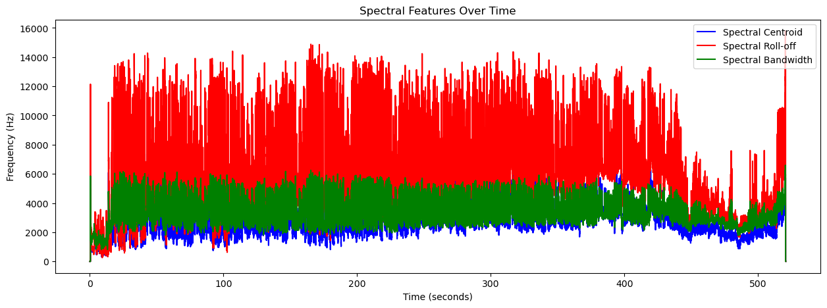

In [ ]:

zero_crossings **=** librosa**.**zero_crossings(y, pad**=False**)

print("Total Zero Crossings:", sum(zero_crossings))

Total Zero Crossings: 1518424

In [ ]:

*# Load the audio file*

y, sr **=** librosa**.**load('09 Purple Rain.wav', sr**=None**)

*# Extract features*

spectrogram **=** librosa**.**feature**.**melspectrogram(y**=**y, sr**=**sr)

*# Convert to decibels*

spectrogram_db **=** librosa**.**power_to_db(spectrogram, ref**=**np**.**max)

*# Setup for plotting*

fig, ax **=** plt**.**subplots(1, 1, figsize**=**(10, 10), subplot_kw**=**{'projection': 'polar'})

ax**.**axis('off')

*# Create the meshgrid for the spectrogram plot*

*# Ensure theta and r have one more point than the spectrogram_db dimensions*

theta **=** np**.**linspace(0, 2**\***np**.**pi, spectrogram_db**.**shape[1] **+** 1)

r **=** np**.**linspace(0, 1, spectrogram_db**.**shape[0] **+** 1)

theta, r **=** np**.**meshgrid(theta, r)

*# Plot the spectrogram*

ax**.**pcolormesh(theta, r, spectrogram_db, shading**=**'flat')

plt**.**show()

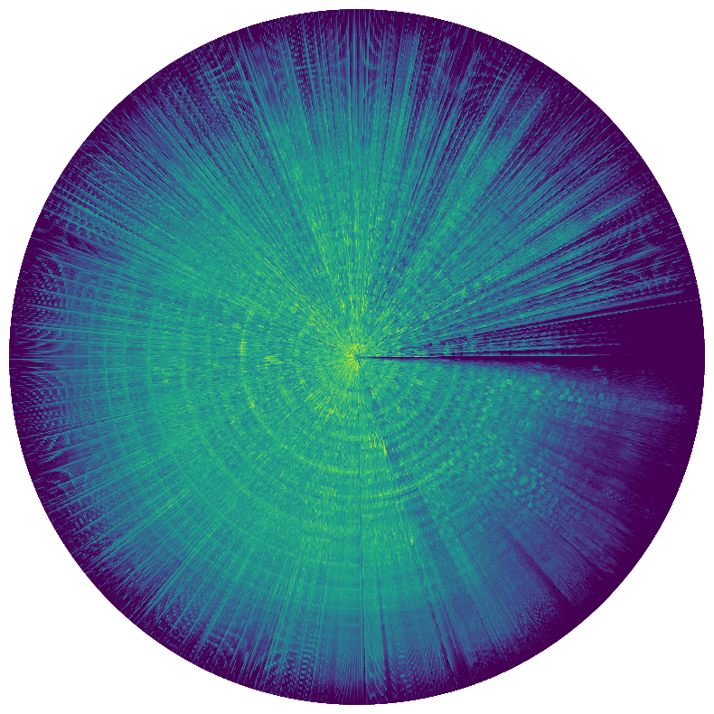

In [ ]:

*# Load the audio file*

y, sr **=** librosa**.**load('09 Purple Rain.wav', sr**=None**)

*# Extract features*

chromagram **=** librosa**.**feature**.**chroma_stft(y**=**y, sr**=**sr)

*# Setup for plotting*

fig, ax **=** plt**.**subplots(1, 1, figsize**=**(10, 10), subplot_kw**=**{'projection': 'polar'})

ax**.**axis('off')

*# Create the meshgrid for the chromagram plot*

*# Ensure theta and r have one more point than the chromagram dimensions*

chroma_theta **=** np**.**linspace(0, 2**\***np**.**pi, chromagram**.**shape[1] **+** 1)

chroma_r **=** np**.**linspace(1, 1.1, chromagram**.**shape[0] **+** 1)

chroma_theta, chroma_r **=** np**.**meshgrid(chroma_theta, chroma_r)

*# Plot the chromagram*

ax**.**pcolormesh(chroma_theta, chroma_r, chromagram, shading**=**'flat')

plt**.**show()

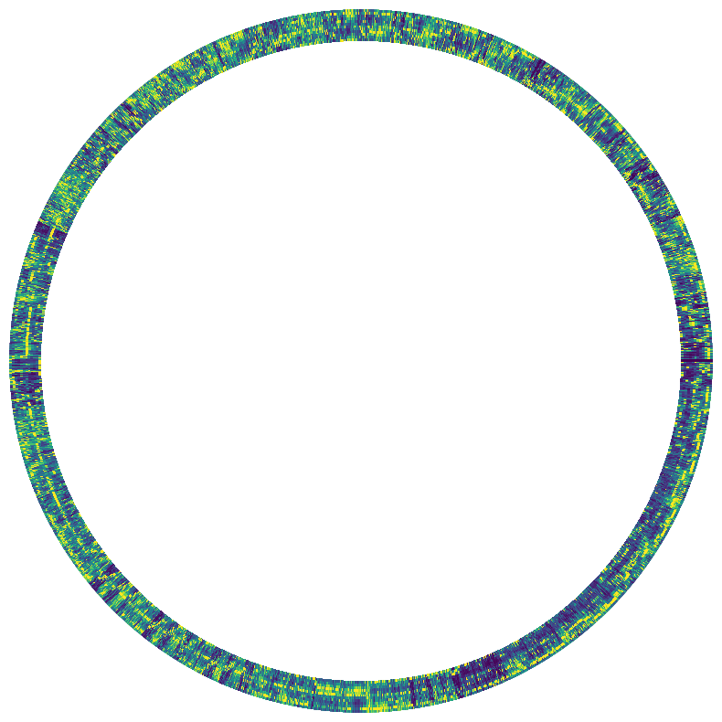

In [ ]:

**import** librosa

**import** numpy **as** np

**import** matplotlib.pyplot **as** plt

*# Load the audio file*

y, sr **=** librosa**.**load('09 Purple Rain.wav', sr**=None**)

*# Extract features*

spectrogram **=** librosa**.**feature**.**melspectrogram(y**=**y, sr**=**sr)

chromagram **=** librosa**.**feature**.**chroma_stft(y**=**y, sr**=**sr)

*# Convert spectrogram to decibels*

spectrogram_db **=** librosa**.**power_to_db(spectrogram, ref**=**np**.**max)

*# Setup for plotting*

fig, ax **=** plt**.**subplots(1, 1, figsize**=**(10, 10), subplot_kw**=**{'projection': 'polar'})

ax**.**axis('off')

*# Spectrogram grid*

theta **=** np**.**linspace(0, 2 **\*** np**.**pi, spectrogram_db**.**shape[1] **+** 1)

r **=** np**.**linspace(0, 1, spectrogram_db**.**shape[0] **+** 1)

theta_grid, r_grid **=** np**.**meshgrid(theta, r)

*# Chromagram grid*

chroma_theta **=** np**.**linspace(0, 2 **\*** np**.**pi, chromagram**.**shape[1] **+** 1)

chroma_r **=** np**.**linspace(1.05, 1.15, chromagram**.**shape[0] **+** 1) *# Adjusted to sit just outside the spectrogram*

chroma_theta_grid, chroma_r_grid **=** np**.**meshgrid(chroma_theta, chroma_r)

*# Plot the spectrogram*

ax**.**pcolormesh(theta_grid, r_grid, spectrogram_db, shading**=**'flat')

*# Plot the chromagram*

ax**.**pcolormesh(chroma_theta_grid, chroma_r_grid, chromagram, shading**=**'flat', cmap**=**'viridis') *# Optionally set a different colormap*

plt**.**show()

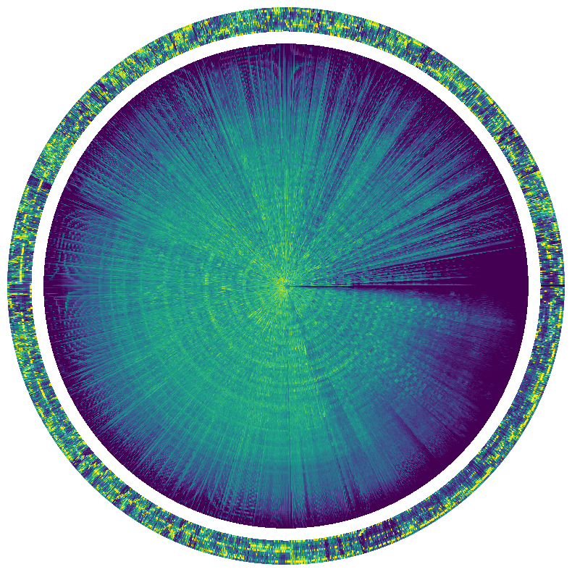

In [ ]:

**import** librosa

**import** numpy **as** np

**import** matplotlib.pyplot **as** plt

*# Load the audio file*

y, sr **=** librosa**.**load('09 Purple Rain.wav', sr**=None**)

*# Extract features*

spectrogram **=** librosa**.**feature**.**melspectrogram(y**=**y, sr**=**sr)

spectrogram_db **=** librosa**.**power_to_db(spectrogram, ref**=**np**.**max)

chromagram **=** librosa**.**feature**.**chroma_stft(y**=**y, sr**=**sr)

*# Setup for plotting*

fig, ax **=** plt**.**subplots(1, 1, figsize**=**(10, 10), subplot_kw**=**{'projection': 'polar'})

ax**.**axis('off')

*# Setup mesh for spectrogram*

theta **=** np**.**linspace(0, 2**\***np**.**pi, spectrogram_db**.**shape[1] **+** 1)

r **=** np**.**linspace(0, 1, spectrogram_db**.**shape[0] **+** 1)

theta, r **=** np**.**meshgrid(theta, r)

ax**.**pcolormesh(theta, r, spectrogram_db, shading**=**'flat')

*# Setup mesh for chromagram*

chroma_theta **=** np**.**linspace(0, 2**\***np**.**pi, chromagram**.**shape[1] **+** 1)

chroma_r **=** np**.**linspace(1, 1.1, chromagram**.**shape[0] **+** 1)

chroma_theta, chroma_r **=** np**.**meshgrid(chroma_theta, chroma_r)

ax**.**pcolormesh(chroma_theta, chroma_r, chromagram, shading**=**'flat', cmap**=**'cool')

plt**.**show()

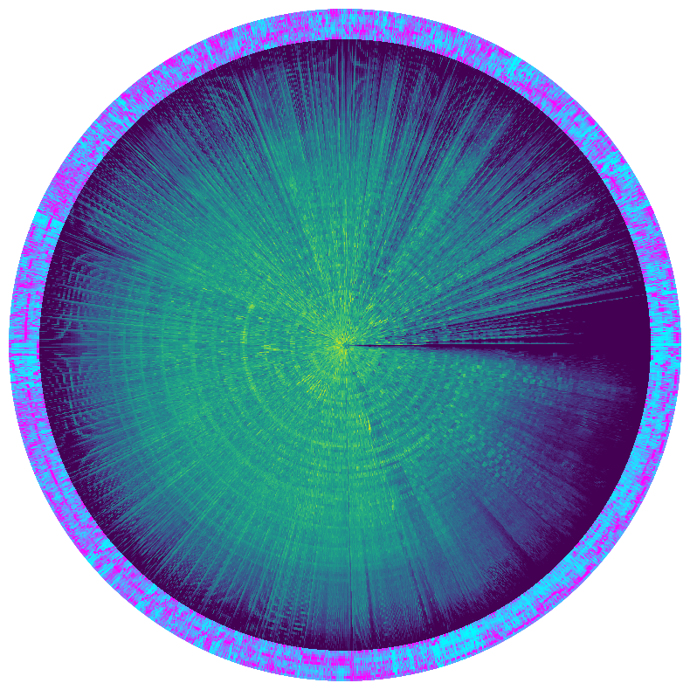

In [ ]:

*# Load the audio file at a lower sampling rate*

y, sr **=** librosa**.**load('09 Purple Rain.wav', sr**=**22050) *# Downsample to 22050 Hz if higher*

In [ ]:

*# Load the full audio but trim to first 30 seconds*

y, sr **=** librosa**.**load('09 Purple Rain.wav', sr**=None**, duration**=**30) *# Only load first 30 seconds*

In [ ]:

*# Use fewer mel bands and a larger hop length*

melspectrogram **=** librosa**.**feature**.**melspectrogram(y**=**y, sr**=**sr, n_mels**=**64, hop_length**=**1024)

In [ ]:

*# Convert data to float16 for processing to save space*

melspectrogram **=** melspectrogram**.**astype(np**.**float16)

In [ ]:

**import** librosa

**import** numpy **as** np

**import** matplotlib.pyplot **as** plt

*# Load the audio file*

y, sr **=** librosa**.**load('09 Purple Rain.wav', sr**=**22050) *# Reduced sampling rate*

*# Extract features*

melspectrogram **=** librosa**.**feature**.**melspectrogram(y**=**y, sr**=**sr, n_mels**=**64, hop_length**=**1024)

chromagram **=** librosa**.**feature**.**chroma_stft(y**=**y, sr**=**sr, hop_length**=**1024)

spectral_contrast **=** librosa**.**feature**.**spectral_contrast(y**=**y, sr**=**sr, hop_length**=**1024)

tonnetz **=** librosa**.**feature**.**tonnetz(y**=**y, sr**=**sr)

harmonic, percussive **=** librosa**.**effects**.**hpss(y)

*# Convert to decibels for the melspectrogram*

melspectrogram_db **=** librosa**.**power_to_db(melspectrogram, ref**=**np**.**max)

*# Normalize and prepare for padding*

features **=** [melspectrogram_db, chromagram, spectral_contrast, tonnetz, harmonic]

features_padded **=** []

**for** f **in** features:

*# Check if the feature is 1D or 2D and apply appropriate padding*

**if** f**.**ndim **==** 1:

*# It's a 1D array*

padded **=** np**.**pad(f, (0, max(0, 500 **-** f**.**shape[0])), mode**=**'constant', constant_values**=**0)

padded **=** padded[np**.**newaxis, :] *# Make it 2D by adding an axis*

**else**:

*# It's a 2D array*

padded **=** np**.**pad(f, ((0, 0), (0, max(0, 500 **-** f**.**shape[1]))), mode**=**'constant', constant_values**=**0)

features_padded**.**append(padded)

*# Visualizing a portion to manage memory*

plt**.**figure(figsize**=**(10, 4))

plt**.**imshow(features_padded[0], aspect**=**'auto', origin**=**'lower')

plt**.**title('Reduced Melspectrogram')

plt**.**colorbar()

plt**.**show()

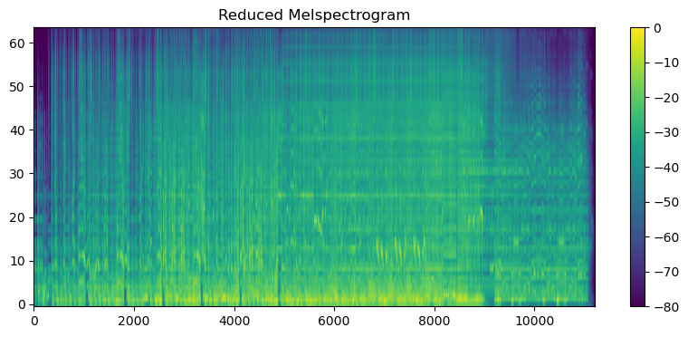

**Goal Make Scatter Plot on Polar Axis**

In [ ]:

**import** librosa

**import** numpy **as** np

**import** matplotlib.pyplot **as** plt

*# Load a segment of the audio file*

y, sr **=** librosa**.**load('09 Purple Rain.wav', sr**=**22050, duration**=**60) *# Load only the first 60 seconds*

*# Extract features with a larger hop_length to reduce data size*

melspectrogram **=** librosa**.**feature**.**melspectrogram(y**=**y, sr**=**sr, n_mels**=**32, hop_length**=**2048)

chromagram **=** librosa**.**feature**.**chroma_stft(y**=**y, sr**=**sr, n_chroma**=**12, hop_length**=**2048)

spectral_contrast **=** librosa**.**feature**.**spectral_contrast(y**=**y, sr**=**sr, hop_length**=**2048)

tonnetz **=** librosa**.**feature**.**tonnetz(y**=**y, sr**=**sr)

harmonic, percussive **=** librosa**.**effects**.**hpss(y)

*# Convert to decibels for the melspectrogram*

melspectrogram_db **=** librosa**.**power_to_db(melspectrogram, ref**=**np**.**max)

*# Normalize and prepare for visualization*

features **=** [melspectrogram_db, chromagram, spectral_contrast, tonnetz, harmonic]

feature_names **=** ['Mel Spectrogram', 'Chromagram', 'Spectral Contrast', 'Tonnetz', 'Harmonic']

*# Create a figure with subplots for each feature*

fig, axes **=** plt**.**subplots(len(features), 1, figsize**=**(8, 15), subplot_kw**=**{'projection': 'polar'})

*# Plot each feature in a separate subplot*

**for** ax, feature, name **in** zip(axes, features, feature_names):

**if** feature**.**ndim **>** 1:

*# Average the feature over its rows to reduce complexity*

feature **=** np**.**mean(feature, axis**=**0)

theta **=** np**.**linspace(0, 2 **\*** np**.**pi, num**=**feature**.**shape[0])

r **=** feature *# Magnitude as radius*

ax**.**scatter(theta, r)

ax**.**set_title(name)

ax**.**set_ylim(0, np**.**max(r) **+** 0.1) *# Adjust the limits*

plt**.**tight_layout()

plt**.**show()

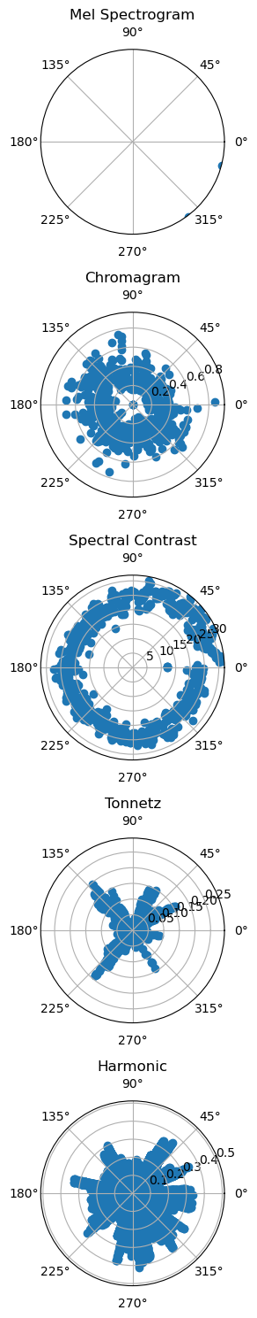

In [ ]:

**import** librosa

**import** numpy **as** np

**import** matplotlib.pyplot **as** plt

*# Load a segment of the audio file*

y, sr **=** librosa**.**load('09 Purple Rain.wav', sr**=**22050, duration**=**60) *# Load only the first 60 seconds*

*# Extract features with a larger hop_length to reduce data size*

melspectrogram **=** librosa**.**feature**.**melspectrogram(y**=**y, sr**=**sr, n_mels**=**32, hop_length**=**2048)

chromagram **=** librosa**.**feature**.**chroma_stft(y**=**y, sr**=**sr, n_chroma**=**12, hop_length**=**2048)

spectral_contrast **=** librosa**.**feature**.**spectral_contrast(y**=**y, sr**=**sr, hop_length**=**2048)

tonnetz **=** librosa**.**feature**.**tonnetz(y**=**y, sr**=**sr)

harmonic, percussive **=** librosa**.**effects**.**hpss(y)

*# Convert to decibels for the melspectrogram*

melspectrogram_db **=** librosa**.**power_to_db(melspectrogram, ref**=**np**.**max)

*# Normalize and prepare for visualization*

features **=** [melspectrogram_db, chromagram, spectral_contrast, tonnetz, harmonic]

feature_names **=** ['Mel Spectrogram', 'Chromagram', 'Spectral Contrast', 'Tonnetz', 'Harmonic']

colors **=** ['red', 'green', 'blue', 'purple', 'orange'] *# Assign a color to each feature*

*# Create a polar plot*

fig, ax **=** plt**.**subplots(1, 1, figsize**=**(10, 8), subplot_kw**=**{'projection': 'polar'})

*# Plot each feature in the same subplot with different colors*

**for** feature, name, color **in** zip(features, feature_names, colors):

**if** feature**.**ndim **>** 1:

*# Average the feature over its rows to reduce complexity*

feature **=** np**.**mean(feature, axis**=**0)

theta **=** np**.**linspace(0, 2 **\*** np**.**pi, num**=**feature**.**shape[0])

r **=** feature *# Magnitude as radius*

ax**.**scatter(theta, r, label**=**name, color**=**color, alpha**=**0.75, s**=**10) *# Use smaller dots with some transparency*

ax**.**set_title('Audio Features Overlaid on Polar Plot')

ax**.**legend(loc**=**'upper right', bbox_to_anchor**=**(1.1, 1.1)) *# Adjust legend position outside the plot*

plt**.**show()

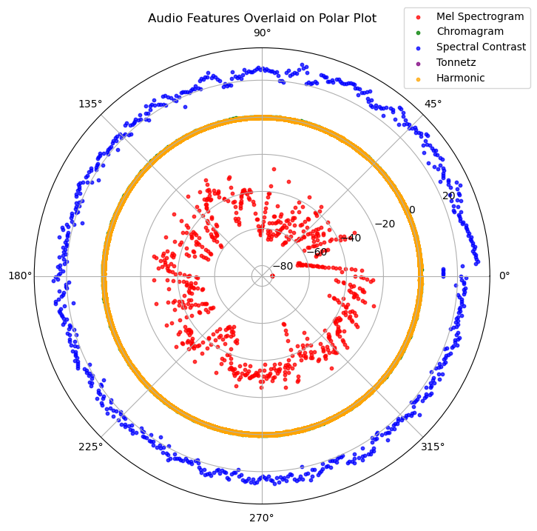

In [ ]:

*# Load a segment of the audio file*

y, sr **=** librosa**.**load('09 Purple Rain.wav', sr**=**22050, duration**=**60) *# Load only the first 60 seconds*

*# Extract features with a larger hop_length to reduce data size*

melspectrogram **=** librosa**.**feature**.**melspectrogram(y**=**y, sr**=**sr, n_mels**=**32, hop_length**=**2048)

chromagram **=** librosa**.**feature**.**chroma_stft(y**=**y, sr**=**sr, n_chroma**=**12, hop_length**=**2048)

spectral_contrast **=** librosa**.**feature**.**spectral_contrast(y**=**y, sr**=**sr, hop_length**=**2048)

tonnetz **=** librosa**.**feature**.**tonnetz(y**=**y, sr**=**sr)

harmonic, percussive **=** librosa**.**effects**.**hpss(y)

*# Convert to decibels for the melspectrogram*

melspectrogram_db **=** librosa**.**power_to_db(melspectrogram, ref**=**np**.**max)

*# Normalize and prepare for visualization*

features **=** [melspectrogram_db, chromagram, spectral_contrast, tonnetz, harmonic]

feature_names **=** ['Mel Spectrogram', 'Chromagram', 'Spectral Contrast', 'Tonnetz', 'Harmonic']

colors **=** ['red', 'green', 'blue', 'purple', 'orange'] *# Assign a color to each feature*

*# Create a polar plot*

fig, ax **=** plt**.**subplots(1, 1, figsize**=**(10, 8), subplot_kw**=**{'projection': 'polar'})

*# Plot each feature in the same subplot with different colors*

**for** feature, name, color **in** zip(features, feature_names, colors):

**if** feature**.**ndim **>** 1:

*# Average the feature over its rows to reduce complexity*

feature **=** np**.**mean(feature, axis**=**0)

theta **=** np**.**linspace(0, 2 **\*** np**.**pi, num**=**feature**.**shape[0])

r **=** feature *# Magnitude as radius*

ax**.**scatter(theta, r, label**=**name, color**=**color, alpha**=**0.75, s**=**10) *# Use smaller dots with some transparency*

ax**.**set_title('Audio Features Overlaid on Polar Plot')

ax**.**legend(loc**=**'upper right', bbox_to_anchor**=**(1.1, 1.1)) *# Adjust legend position outside the plot*

*# Remove the polar labels*

ax**.**set_xticklabels([])

*# Remove the radial labels*

ax**.**set_yticklabels([])

*# Remove the grid*

ax**.**grid(**False**)

*# Remove the outer circle (spine)*

ax**.**spines['polar']**.**set_visible(**False**)

*# Optionally, if you want to remove the radial ticks as well:*

ax**.**yaxis**.**set_ticks([])

*# Show the plot without the polar labels and grid*

plt**.**show()

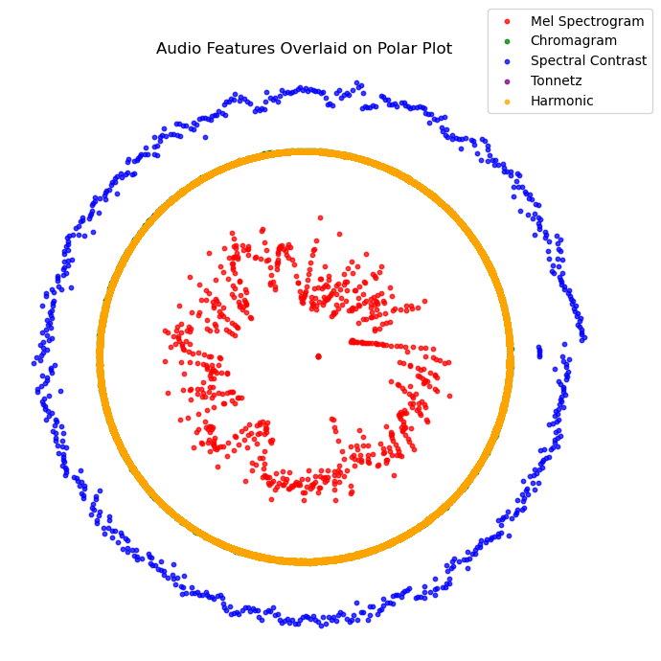

In [ ]:

**import** librosa

**import** numpy **as** np

**import** matplotlib.pyplot **as** plt

*# Load a segment of the audio file*

y, sr **=** librosa**.**load('09 Purple Rain.wav', sr**=**22050, duration**=**60) *# Load only the first 60 seconds*

*# Extract features*

melspectrogram **=** librosa**.**feature**.**melspectrogram(y**=**y, sr**=**sr, n_mels**=**32, hop_length**=**2048)

chromagram **=** librosa**.**feature**.**chroma_stft(y**=**y, sr**=**sr, hop_length**=**2048)

spectral_contrast **=** librosa**.**feature**.**spectral_contrast(y**=**y, sr**=**sr, hop_length**=**2048)

tonnetz **=** librosa**.**feature**.**tonnetz(y**=**y, sr**=**sr)

harmonic, percussive **=** librosa**.**effects**.**hpss(y)

*# Normalize the features to a common scale*

features **=** [melspectrogram, chromagram, spectral_contrast, tonnetz, harmonic]

normalized_features **=** []

**for** feature **in** features:

*# Scale features to be between 0 and 1*

min_val **=** np**.**min(feature)

max_val **=** np**.**max(feature)

scaled_feature **=** (feature **-** min_val) **/** (max_val **-** min_val)

normalized_features**.**append(scaled_feature)

*# Create a polar plot*

fig, ax **=** plt**.**subplots(figsize**=**(10, 8), subplot_kw**=**{'projection': 'polar'})

feature_names **=** ['Mel Spectrogram', 'Chromagram', 'Spectral Contrast', 'Tonnetz', 'Harmonic']

colors **=** ['red', 'green', 'blue', 'purple', 'orange'] *# Assign a color to each feature*

*# Plot each normalized feature in the same subplot with different colors*

**for** feature, name, color **in** zip(normalized_features, feature_names, colors):

*# Collapse feature dimensions if necessary*

**if** feature**.**ndim **>** 1:

feature **=** np**.**mean(feature, axis**=**0)

*# Map to polar coordinates*

theta **=** np**.**linspace(0, 2 **\*** np**.**pi, feature**.**size)

r **=** feature

ax**.**scatter(theta, r, alpha**=**0.75, s**=**10, label**=**name, color**=**color) *# Use smaller dots with some transparency*

*# Remove the polar labels*

ax**.**set_xticklabels([])

*# Remove the radial labels and grids*

ax**.**set_yticklabels([])

ax**.**grid(**False**)

*# Remove the outer circle (spine)*

ax**.**spines['polar']**.**set_visible(**False**)

*# Optionally, if you want to remove the radial ticks as well:*

ax**.**yaxis**.**set_ticks([])

*# Add a legend*

ax**.**legend(loc**=**'upper right', bbox_to_anchor**=**(1.1, 1.1))

*# Show the plot*

plt**.**show()

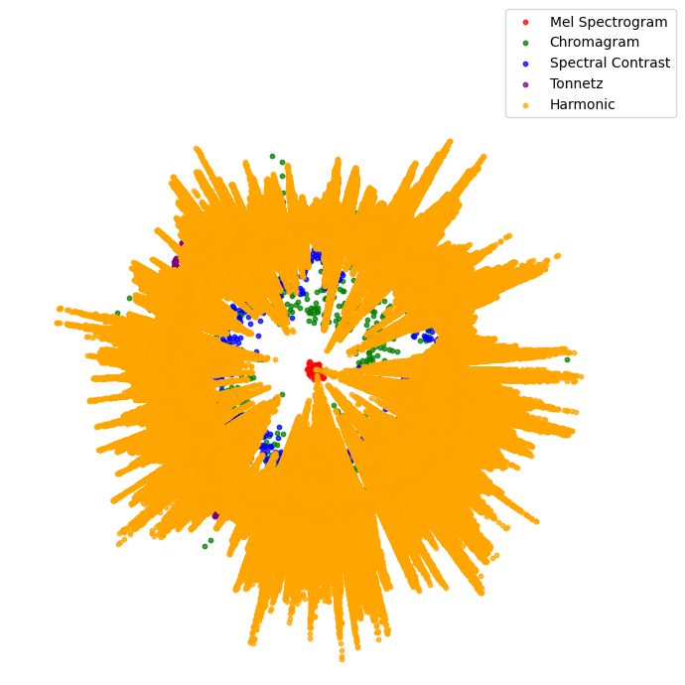

In [ ]:

**import** librosa

**import** numpy **as** np

**import** matplotlib.pyplot **as** plt

*# Load a segment of the audio file*

y, sr **=** librosa**.**load('09 Purple Rain.wav', sr**=**22050, duration**=**60) *# Load only the first 60 seconds*

*# Extract features*

melspectrogram **=** librosa**.**feature**.**melspectrogram(y**=**y, sr**=**sr, n_mels**=**32, hop_length**=**2048)

chromagram **=** librosa**.**feature**.**chroma_stft(y**=**y, sr**=**sr, hop_length**=**2048)

spectral_contrast **=** librosa**.**feature**.**spectral_contrast(y**=**y, sr**=**sr, hop_length**=**2048)

tonnetz **=** librosa**.**feature**.**tonnetz(y**=**y, sr**=**sr)

harmonic, percussive **=** librosa**.**effects**.**hpss(y)

*# Normalize the features to a common scale*

features **=** [harmonic, melspectrogram, chromagram, spectral_contrast, tonnetz] *# Place harmonic first*

feature_names **=** ['Harmonic', 'Mel Spectrogram', 'Chromagram', 'Spectral Contrast', 'Tonnetz']

colors **=** ['orange', 'red', 'green', 'blue', 'purple'] *# Corresponding colors, with harmonic's color first*

normalized_features **=** []

**for** feature **in** features:

*# Scale features to be between 0 and 1*

min_val **=** np**.**min(feature)

max_val **=** np**.**max(feature)

scaled_feature **=** (feature **-** min_val) **/** (max_val **-** min_val)

normalized_features**.**append(scaled_feature)

*# Create a polar plot*

fig, ax **=** plt**.**subplots(figsize**=**(10, 8), subplot_kw**=**{'projection': 'polar'})

*# Plot each normalized feature in the same subplot with different colors*

**for** feature, name, color **in** zip(normalized_features, feature_names, colors):

*# Collapse feature dimensions if necessary*

**if** feature**.**ndim **>** 1:

feature **=** np**.**mean(feature, axis**=**0)

*# Map to polar coordinates*

theta **=** np**.**linspace(0, 2 **\*** np**.**pi, feature**.**size)

r **=** feature

ax**.**scatter(theta, r, alpha**=**0.75, s**=**10, label**=**name, color**=**color) *# Use smaller dots with some transparency*

*# Customize the plot - removing labels, ticks, and spines*

ax**.**set_xticklabels([])

ax**.**set_yticklabels([])

ax**.**grid(**False**)

ax**.**spines['polar']**.**set_visible(**False**)

ax**.**yaxis**.**set_ticks([])

*# Add a legend*

ax**.**legend(loc**=**'upper right', bbox_to_anchor**=**(1.1, 1.1))

*# Show the plot*

plt**.**show()

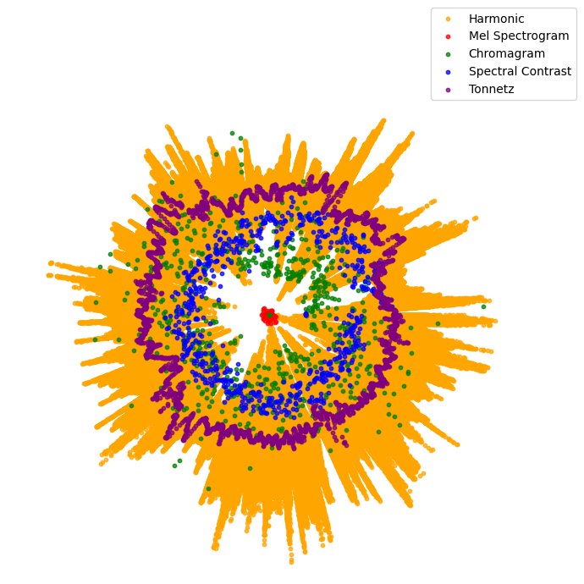

**Goal Make Scatterplot Polar Plot**

In [ ]:

**import** plotly.graph_objects **as** go

**import** numpy **as** np

**import** librosa

*# Load a segment of the audio file*

y, sr **=** librosa**.**load('09 Purple Rain.wav', sr**=**22050, duration**=**60) *# Load only the first 60 seconds*

*# Extract features*

melspectrogram **=** librosa**.**feature**.**melspectrogram(y**=**y, sr**=**sr, n_mels**=**32, hop_length**=**2048)

chromagram **=** librosa**.**feature**.**chroma_stft(y**=**y, sr**=**sr, hop_length**=**2048)

spectral_contrast **=** librosa**.**feature**.**spectral_contrast(y**=**y, sr**=**sr, hop_length**=**2048)

tonnetz **=** librosa**.**feature**.**tonnetz(y**=**y, sr**=**sr)

harmonic, percussive **=** librosa**.**effects**.**hpss(y)

*# Normalize the features to a common scale*

features **=** [harmonic, melspectrogram, chromagram, spectral_contrast, tonnetz]

feature_names **=** ['Harmonic', 'Mel Spectrogram', 'Chromagram', 'Spectral Contrast', 'Tonnetz']

colors **=** ['orange', 'red', 'green', 'blue', 'purple'] *# Colors for each feature*

normalized_features **=** []

**for** feature **in** features:

*# Scale features to be between 0 and 1*

min_val **=** np**.**min(feature)

max_val **=** np**.**max(feature)

scaled_feature **=** (feature **-** min_val) **/** (max_val **-** min_val)

normalized_features**.**append(scaled_feature)

*# Create a Plotly figure*

fig **=** go**.**Figure()

*# Add traces for each feature*

**for** feature, name, color **in** zip(normalized_features, feature_names, colors):

**if** feature**.**ndim **>** 1:

feature **=** np**.**mean(feature, axis**=**0)

theta **=** np**.**linspace(0, 360, feature**.**size) *# Plotly uses degrees instead of radians*

r **=** feature

fig**.**add_trace(go**.**Scatterpolar(

r**=**r,

theta**=**theta,

mode**=**'markers',

name**=**name,

marker**=**dict(color**=**color)

))

*# Update layout to clean up the plot*

fig**.**update_layout(

polar**=**dict(

radialaxis**=**dict(showticklabels**=False**, ticks**=**''),

angularaxis**=**dict(showticklabels**=False**, ticks**=**'')

),

showlegend**=True**

)

*# Export to HTML*

fig**.**write_html("interactive_plot.html")

print("Interactive plot created successfully.")

Interactive plot created successfully.

In [ ]:

y, sr **=** librosa**.**load('14 Free Fallin.wav')

print('y:', y, '\n')

y: [0. 0. 0. ... 0. 0. 0.]

madonna pearl jam tom petty nirvana prince

In [ ]:

print('y shape:', np**.**shape(y), '\n')

y shape: (5637344,)

In [ ]:

print('Sample Rate (KHz):', sr, '\n')

Sample Rate (KHz): 22050

In [ ]:

print('Check Length of the audio in second:', 5637344**/**22050)

Check Length of the audio in second: 255.66185941043085

In [ ]:

*# Trim leading and trailing silence from an audio signal (silence before and after the actual audio)*

audio_file, _ **=** librosa**.**effects**.**trim(y)

*# the result is an numpy ndarray*

print('Audio File:', audio_file, '\n')

Audio File: [-9.0949470e-13 -1.3642421e-12 9.0949470e-12 ... 8.3927749e-05

1.1652079e-05 -2.1102940e-05]

In [ ]:

print('Audio File shape:', np**.**shape(audio_file))

Audio File shape: (5571584,)

In [ ]:

plt**.**figure(figsize **=** (16, 6))

Out[ ]:

<Figure size 1600x600 with 0 Axes>

<Figure size 1600x600 with 0 Axes>

In [ ]:

librosa**.**display**.**waveshow(y **=** audio_file, sr **=** sr, color **=** "#A300F9");

plt**.**title("Free Fallin", fontsize **=** 23);

plt**.**show()

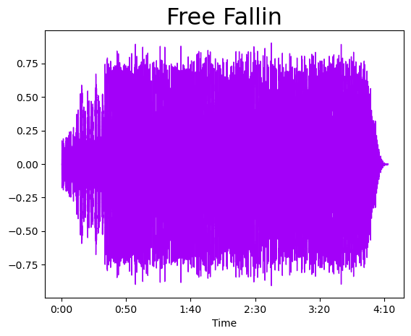

In [ ]:

*# Default FFT window size*

n_fft **=** 2048 *# FFT window size*

hop_length **=** 512 *# number audio of frames between STFT columns (looks like a good default)*

*# Short-time Fourier transform (STFT)*

D **=** np**.**abs(librosa**.**stft(audio_file, n_fft **=** n_fft, hop_length **=** hop_length))

print('Shape of D object:', np**.**shape(D))

Shape of D object: (1025, 10883)

In [ ]:

plt**.**figure(figsize **=** (16, 6))

Out[ ]:

<Figure size 1600x600 with 0 Axes>

<Figure size 1600x600 with 0 Axes>

In [ ]:

plt**.**plot(D);

plt**.**show()

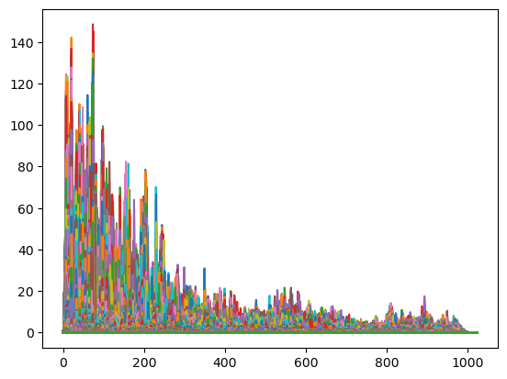

In [ ]:

*# Convert an amplitude spectrogram to Decibels-scaled spectrogram.*

DB **=** librosa**.**amplitude_to_db(D, ref **=** np**.**max)

*# Creating the Spectogram*

plt**.**figure(figsize **=** (16, 6))

Out[ ]:

<Figure size 1600x600 with 0 Axes>

<Figure size 1600x600 with 0 Axes>

In [ ]:

librosa**.**display**.**specshow(DB, sr **=** sr, hop_length **=** hop_length, x_axis **=** 'time', y_axis **=** 'log', cmap **=** 'cool')

Out[ ]:

<matplotlib.collections.QuadMesh at 0x2d5a2e73a50>

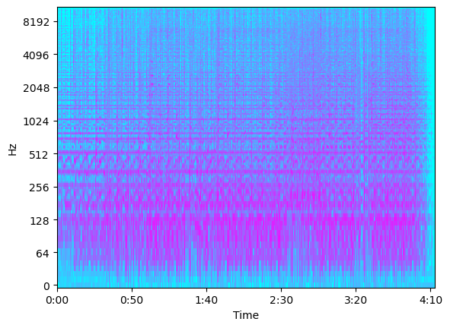

In [ ]:

*# Load audio file*

y, sr **=** librosa**.**load('14 Free Fallin.wav')

*# Compute the Mel-scaled spectrogram*

S **=** librosa**.**feature**.**melspectrogram(y**=**y, sr**=**sr)

*# Convert the amplitude to decibels*

S_DB **=** librosa**.**power_to_db(S, ref**=**np**.**max)

*# Plot the spectrogram*

plt**.**figure(figsize**=**(10, 4))

mappable **=** librosa**.**display**.**specshow(S_DB, sr**=**sr, x_axis**=**'time', y_axis**=**'mel')

*# Create colorbar*

plt**.**colorbar(mappable, format**=**'%+2.0f dB')

plt**.**title('Mel-frequency spectrogram')

plt**.**tight_layout()

plt**.**show()

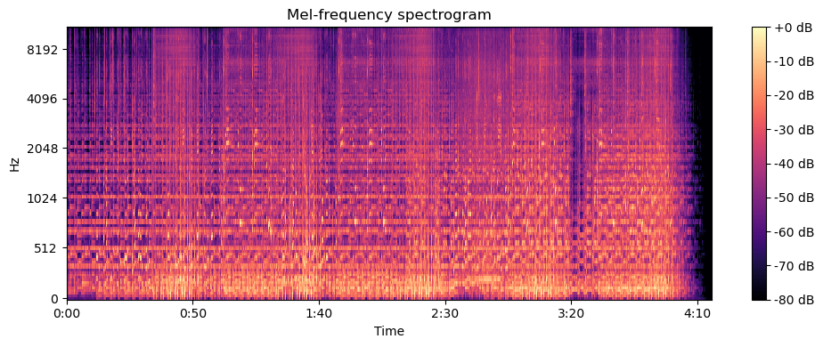

In [ ]:

**from** tensorflow.keras.models **import** Sequential

**from** tensorflow.keras.layers **import** Conv2D, MaxPooling2D, Flatten, Dense

model **=** Sequential([

Conv2D(32, (3, 3), activation**=**'relu', input_shape**=**(128, 128, 1)), *# Adjust input shape to match your data*

MaxPooling2D(2, 2),

Conv2D(64, (3, 3), activation**=**'relu'),

MaxPooling2D(2, 2),

Flatten(),

Dense(64, activation**=**'relu'),

Dense(10, activation**=**'softmax') *# Adjust the final layer based on the number of genres*

])

model**.**compile(optimizer**=**'adam', loss**=**'categorical_crossentropy', metrics**=**['accuracy'])

In [ ]:

**from** tensorflow.keras.models **import** Sequential

**from** tensorflow.keras.layers **import** Conv2D, MaxPooling2D, Flatten, Dense

model **=** Sequential([

Conv2D(32, (3, 3), activation**=**'relu', input_shape**=**(128, 128, 1)), *# Adjust input shape to match your data*

MaxPooling2D(2, 2),

Conv2D(64, (3, 3), activation**=**'relu'),

MaxPooling2D(2, 2),

Flatten(),

Dense(64, activation**=**'relu'),

Dense(10, activation**=**'softmax') *# Adjust the final layer based on the number of genres*

])

model**.**compile(optimizer**=**'adam', loss**=**'categorical_crossentropy', metrics**=**['accuracy'])

In [ ]:

print(model)

<Sequential name=sequential_2, built=True>

In [ ]:

y, sr **=** librosa**.**load('14 Free Fallin.wav')

y, _ **=** librosa**.**effects**.**trim(y)

In [ ]:

**import** librosa

**import** librosa.display

**import** matplotlib.pyplot **as** plt

**import** numpy **as** np

*# Load an audio file*

y, sr **=** librosa**.**load('14 Free Fallin.wav')

*# Compute Mel spectrogram using keyword arguments explicitly*

S **=** librosa**.**feature**.**melspectrogram(y**=**y, sr**=**sr) *# Notice y=y and sr=sr are now explicitly named*

*# Convert to log scale (dB)*

S_DB **=** librosa**.**power_to_db(S, ref**=**np**.**max)

*# Display the spectrogram*

plt**.**figure(figsize**=**(10, 4))

librosa**.**display**.**specshow(S_DB, sr**=**sr, hop_length**=**512, x_axis**=**'time', y_axis**=**'log', cmap**=**'cool')

plt**.**colorbar(format**=**'%+2.0f dB')

plt**.**title("Mel Spectrogram", fontsize**=**23)

plt**.**show()

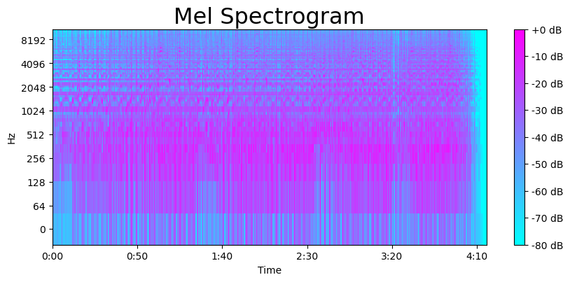

In [ ]:

y_harm, y_perc **=** librosa**.**effects**.**hpss(audio_file)

plt**.**figure(figsize **=** (16, 6))

Out[ ]:

<Figure size 1600x600 with 0 Axes>

<Figure size 1600x600 with 0 Axes>

In [ ]:

*# Total zero_crossings in our 1 song*

zero_crossings **=** librosa**.**zero_crossings(audio_file, pad**=False**)

print(sum(zero_crossings))

594987

In [ ]:

**import** scipy.signal

*# Create a Hann window*

window **=** scipy**.**signal**.**windows**.**hann(5)

In [ ]:

**import** numpy **as** np

**import** scipy.signal.windows

*# Creating a Hann window*

window_length **=** 512 *# Size of the window*

window **=** scipy**.**signal**.**windows**.**hann(window_length)

In [ ]:

*# def patched_beat_track(y, sr):*

*# S, phase = librosa.magphase(librosa.stft(y))*

*# onset_env = librosa.onset.onset_strength(S=S)*

*# tempo, beats = librosa.beat.beat_track(onset_envelope=onset_env, sr=sr)*

*# return tempo*

*# # Using the patched function*

*# tempo = patched_beat_track(y=y, sr=sr)*

*# print("Detected tempo:", tempo)*

In [ ]:

y_harm, y_perc **=** librosa**.**effects**.**hpss(audio_file)

plt**.**figure(figsize **=** (16, 6))

Out[ ]:

<Figure size 1600x600 with 0 Axes>

<Figure size 1600x600 with 0 Axes>

In [ ]:

plt**.**plot(y_harm, color **=** '#A300F9');

plt**.**plot(y_perc, color **=** '#FFB100');

plt**.**show()

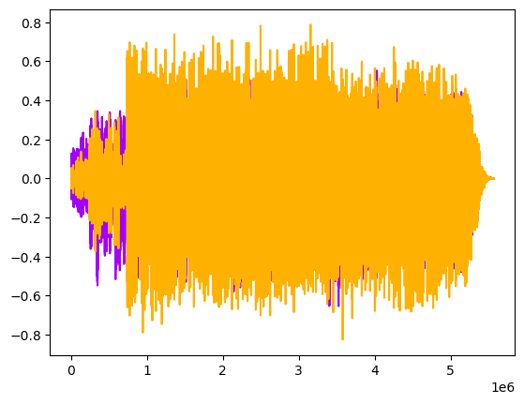

In [ ]:

*# import librosa*

*# # Load audio data*

*# y, sr = librosa.load('14 Free Fallin.wav')*

*# # Correctly calling beat_track with keyword arguments*

*# tempo, _ = librosa.beat.beat_track(y=y, sr=sr)*

*# print("Detected tempo:", tempo)*

**Spectral Centroid**

This variable represents brightness of a sound by calculating the center of sound spectrum (where the sound signal is at its peak). We can also plot it into a wave form.

In [ ]:

**import** librosa

*# Load audio data*

y, sr **=** librosa**.**load('14 Free Fallin.wav')

*# Calculate the Spectral Centroids using keyword arguments*

spectral_centroids **=** librosa**.**feature**.**spectral_centroid(y**=**y, sr**=**sr)[0]

*# Output the shape and data*

print('Centroids:', spectral_centroids)

Centroids: [0. 0. 0. ... 0. 0. 0.]

In [ ]:

print('Shape of Spectral Centroids:', spectral_centroids**.**shape, '\n')

Shape of Spectral Centroids: (11011,)

In [ ]:

frames **=** range(len(spectral_centroids))

*# Converts frame counts to time (seconds)*

t **=** librosa**.**frames_to_time(frames)

print('frames:', frames, '\n')

frames: range(0, 11011)

In [ ]:

print('t:', t)

t: [0.00000000e+00 2.32199546e-02 4.64399093e-02 ... 2.55605261e+02

2.55628481e+02 2.55651701e+02]

In [ ]:

**def** normalize(x, axis**=**0):

**return** sklearn**.**preprocessing**.**minmax_scale(x, axis**=**axis)

In [ ]:

*#Plotting the Spectral Centroid along the waveform*

plt**.**figure(figsize **=** (16, 6))

Out[ ]:

<Figure size 1600x600 with 0 Axes>

<Figure size 1600x600 with 0 Axes>

In [ ]:

**import** librosa

**import** librosa.display

**import** matplotlib.pyplot **as** plt

**from** sklearn.preprocessing **import** minmax_scale *# Import the specific function*

*# Load your audio file (replace 'path_to_your_audio_file.wav' with your file's path)*

y, sr **=** librosa**.**load('14 Free Fallin.wav')

*# Calculate spectral centroids*

spectral_centroids **=** librosa**.**feature**.**spectral_centroid(y**=**y, sr**=**sr)[0]

*# Time variable for plotting*

t **=** librosa**.**frames_to_time(range(len(spectral_centroids)), sr**=**sr)

*# Normalize the spectral centroids for plotting*

normalized_centroids **=** minmax_scale(spectral_centroids, axis**=**0)

*# Plotting the waveform and the normalized spectral centroids*

librosa**.**display**.**waveshow(y, sr**=**sr, alpha**=**0.4, color**=**'#A300F9')

plt**.**plot(t, normalized_centroids, color**=**'#FFB100')

plt**.**show()

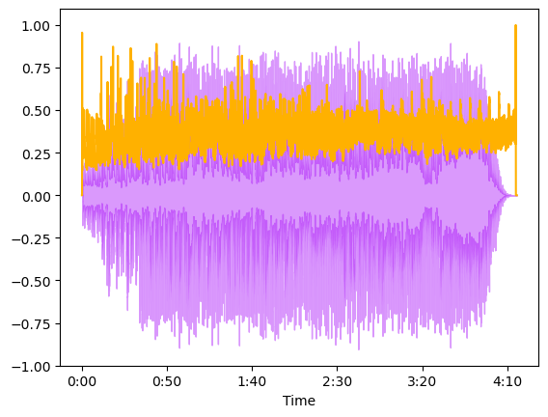

**Spectral Rolloff**

Spectral Rolloff is a frequency below a specified percentage of the total spectral energy. It is like we have a cut-point, and we visualize the sound wave that is below that cut-point. Let’s just call it as another characteristic of a sound.

In [ ]:

**import** librosa

**import** matplotlib.pyplot **as** plt

*# Assuming 'audio_file' is your audio time series and 'sr' is the sample rate*

*# Make sure you've loaded your audio data correctly with librosa.load*

y, sr **=** librosa**.**load('14 Free Fallin.wav')

*# Calculate the Spectral Roll-off using keyword arguments*

spectral_rolloff **=** librosa**.**feature**.**spectral_rolloff(y**=**y, sr**=**sr)[0]

*# The plot*

plt**.**figure(figsize**=**(16, 6))

plt**.**plot(spectral_rolloff, color**=**'b')

plt**.**title('Spectral Roll-off')

plt**.**show()

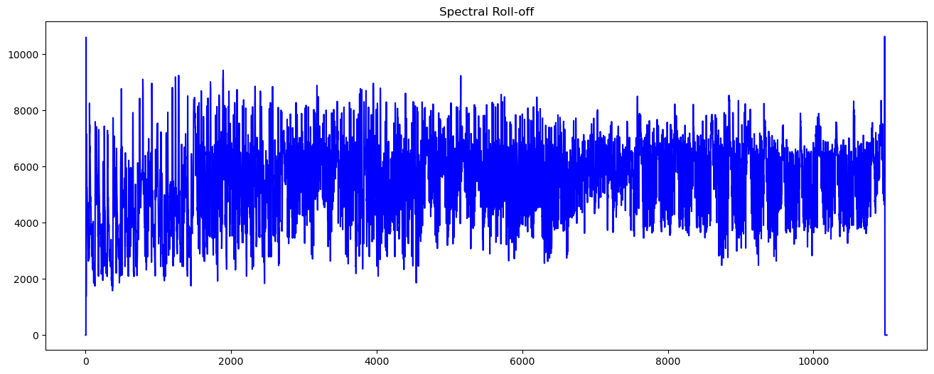

In [ ]:

**import** librosa

**import** librosa.display

**import** matplotlib.pyplot **as** plt

**from** sklearn.preprocessing **import** minmax_scale *# Importing the minmax_scale function*

*# Load your audio file*

y, sr **=** librosa**.**load('14 Free Fallin.wav')

*# Calculate spectral rolloff*

spectral_rolloff **=** librosa**.**feature**.**spectral_rolloff(y**=**y, sr**=**sr)[0]

*# Time variable for plotting, assuming the correct definition of 't'*

t **=** librosa**.**frames_to_time(range(len(spectral_rolloff)), sr**=**sr)

*# Define a normalization function that uses sklearn's minmax_scale*

**def** normalize(x, axis**=**0):

**return** minmax_scale(x, axis**=**axis)

*# Normalize the spectral rolloff for plotting*

normalized_rolloff **=** normalize(spectral_rolloff)

*# Display the waveform and the normalized spectral rolloff*

librosa**.**display**.**waveshow(y, sr**=**sr, alpha**=**0.4, color**=**'#A300F9')

plt**.**plot(t, normalized_rolloff, color**=**'#FFB100')

plt**.**show()

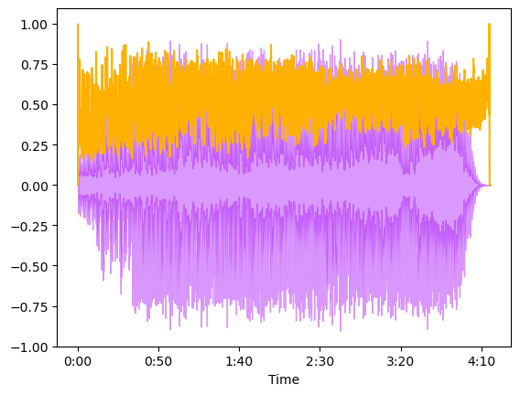

**Mel-Frequency Cepstral Coefficients**

The Mel frequency Cepstral coefficients (MFCCs) of a signal are a small set of features that describes the overall shape of a spectral envelope. It imitates characteristics of human voice.

In [ ]:

**import** librosa

*# Assuming you have loaded your audio file 'audio_file' and have its sample rate 'sr'*

y, sr **=** librosa**.**load('14 Free Fallin.wav')

*# Calculate MFCCs using keyword arguments*

mfccs **=** librosa**.**feature**.**mfcc(y**=**y, sr**=**sr)

*# Print the shape of the MFCCs array to verify*

print('MFCCs shape:', mfccs**.**shape)

MFCCs shape: (20, 11011)

In [ ]:

plt**.**figure(figsize **=** (16, 6))

Out[ ]:

<Figure size 1600x600 with 0 Axes>

<Figure size 1600x600 with 0 Axes>

In [ ]:

librosa**.**display**.**specshow(mfccs, sr**=**sr, x_axis**=**'time', cmap **=** 'cool');

plt**.**show()

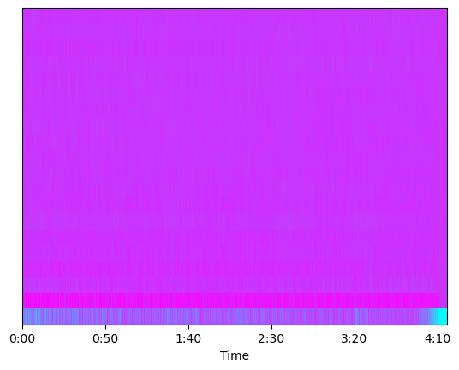

In [ ]:

**from** sklearn.preprocessing **import** scale

**import** librosa

**from** sklearn.preprocessing **import** scale *# Importing the scale function*

*# Assuming you've loaded your audio file and calculated mfccs*

y, sr **=** librosa**.**load('14 Free Fallin.wav')

mfccs **=** librosa**.**feature**.**mfcc(y**=**y, sr**=**sr)

*# Perform feature scaling*

mfccs_scaled **=** scale(mfccs, axis**=**1) *# Scale MFCCs across the feature axis*

*# Print the shape of the scaled MFCCs array to verify*

print('Scaled MFCCs shape:', mfccs_scaled**.**shape)

Scaled MFCCs shape: (20, 11011)

c:\ProgramData\Anaconda3\envs\ml\Lib\site-packages\sklearn\preprocessing\_data.py:261: UserWarning:

Numerical issues were encountered when centering the data and might not be solved. Dataset may contain too large values. You may need to prescale your features.

c:\ProgramData\Anaconda3\envs\ml\Lib\site-packages\sklearn\preprocessing\_data.py:280: UserWarning:

Numerical issues were encountered when scaling the data and might not be solved. The standard deviation of the data is probably very close to 0.

In [ ]:

print('Mean:', mfccs**.**mean(), '\n')

Mean: -1.8536327

In [ ]:

print('Var:', mfccs**.**var())

Var: 1683.6346

In [ ]:

plt**.**figure(figsize **=** (16, 6))

Out[ ]:

<Figure size 1600x600 with 0 Axes>

<Figure size 1600x600 with 0 Axes>

In [ ]:

librosa**.**display**.**specshow(mfccs, sr**=**sr, x_axis**=**'time', cmap **=** 'cool');

plt**.**show()



**Chroma Frequencies**

Chroma feature represents the tone of music or sound by projecting its sound spectrum into a space that represents musical octave. This feature is usually used in chord recognition task.

In [ ]:

**import** librosa

*# Assuming 'audio_file' contains the audio data loaded using librosa.load()*

y, sr **=** librosa**.**load('14 Free Fallin.wav')

hop_length **=** 5000

*# Calculate the Chromagram using keyword arguments*

chromagram **=** librosa**.**feature**.**chroma_stft(y**=**y, sr**=**sr, hop_length**=**hop_length)

*# Print the shape of the Chromagram to verify*

print('Chromogram shape:', chromagram**.**shape)

Chromogram shape: (12, 1128)

In [ ]:

plt**.**figure(figsize**=**(16, 6))

Out[ ]:

<Figure size 1600x600 with 0 Axes>

<Figure size 1600x600 with 0 Axes>

In [ ]:

librosa**.**display**.**specshow(chromagram, x_axis**=**'time', y_axis**=**'chroma', hop_length**=**hop_length, cmap**=**'coolwarm');

plt**.**show()

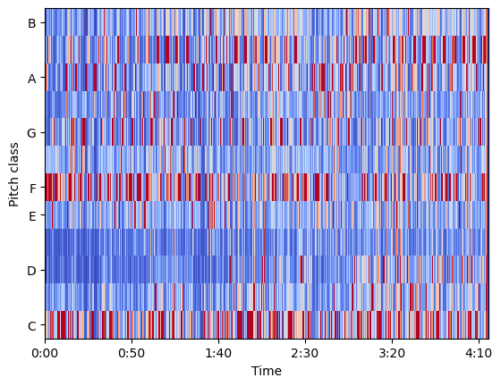

**Exploratory Data Analysis**

We will perform an exploratory data analysis with the features_30_sec.csv data that contains the mean and variance of the features discussed above for all audio file in the data bank. We have 10 genres of music, each genre has 100 audio files. That makes the total of 1000 songs that we have. There are 60 features in total for each song.

In [ ]: